
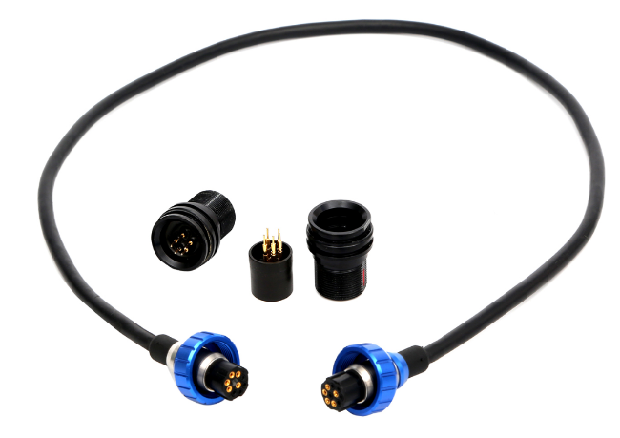




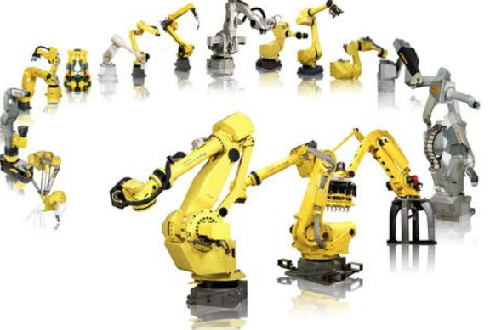


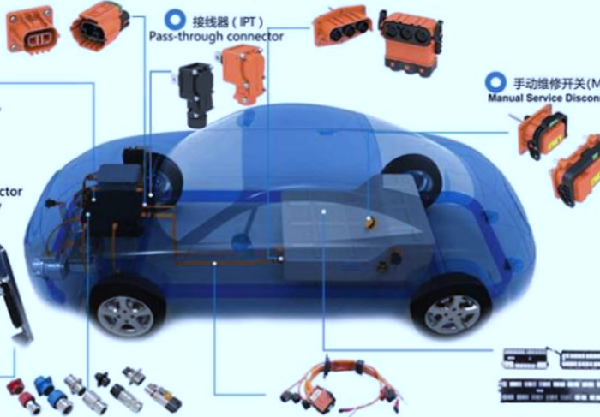



Industrial I/O and Customized Connectors and Cable Assembly

- Industrial Ethernet now links automation technology to standard networks and the Internet world.
- We are proud to lead the way in standard connectors linking the office world to the demanding industrial setting and offer special solutions for cabling and assembling.
- Our I/0 connectors are sealed to an IP67 rating, along with EMC protection. We offer various products, including M12, M8, RJ45, RJ12, USB 2.0 / USB 3.0, Din, Mini-DIN, D-sub, Optical Fiber and customized connector and cable assembly
- TPU over molded or PA+GF housing
- Copper alloy contacts and shell
- Cable length customized, PUR and PVT cable options
- The fire resistance grade of raw cable is optional as below
  - CMP/CMR/CM/CMG/CMX/ VW-1/VW-2/FT-1/FT-2/UL 94 V-0/V-1/V-2/V-3
- Water resistance is optional with IP65/67/68
- Cable bending test is optional with 30℃, 45℃, 90℃

Content Table of Connector and Cable Assembly

- FAKRA and Mini FAKRA Cable Assembly
Products | Pages | Remark
FAKRA female Coding A-Z cable assembly | 5-8 | High Data Rates Up to 8Gbps
FAKRA male Coding A-Z cable assembly | 9-12 | High Data Rates Up to 8Gbps
Mini FAKRA female Coding A-Z cable assembly | 13-16 | High Data Rates Up to 20Gbps

- Energy Storage/Solar Energy/Photovoltaic Cable Assembly
Products | Pages | Remark
Energy Storage: 2+12 Pin Straight, Molded Cable Assembly | 17-18
MC4 Female Straight, Cable Assembly | 19-20
MC4 male Straight, Cable Assembly | 21-22
M23 male straight molded cable assembly for charging/discharging battery | 23-24
M23 male with base cable assembly for charging/discharging battery | 25-26
M23 Female with base, cable assembly for charging/discharging battery | 27-28

- Customized Cable Assembly
Products | Pages | Remark
USB Type C Female, IP68, Cable Assembly (Customized) | 29-30
4P Male IP67 for start system, Cable Assembly (Customized) | 31-32
4P female IP67 for start system Cable Assembly (Customized) | 33-34

- CPC (Plastic) Cable Assembly
Products | Pages | Remark
CPC Female (Series1-6) Cable Assembly | 35-38
CPC male (Series 1-6) Cable Assembly | 39-42

- M12 Cable Assembly
Products | Pages | Remark
M12, A code, female, straight molded, cable assembly | 43-44 | A-coded for sensors, dc power and 1 Gbit Ethernet
M12, A code, male, straight molded, cable assembly | 45-46 | A-coded for sensors, dc power and 1 Gbit Ethernet
M12, A code, female, right angle molded, cable assembly | 47-48 | A-coded for sensors, dc power and 1 Gbit Ethernet
M12, A code, male, right angle molded, cable assembly | 49-50 | A-coded for sensors, dc power and 1 Gbit Ethernet
M12, D code, male, straight molded, cable assembly | 51-52 | D-coded for 100 Mbit Ethernet
M12, D code, female, straight molded, cable assembly | 53-54 | D-coded for 100 Mbit Ethernet
M12, X code male, straight molded, cable assembly | 55-56 | X-coded for 10 Gbit Ethernet

- M8 Cable Assembly
Products | Pages | Remark
M8, A code, female straight molded, cable assembly | 57-58 | Right angle can be customized
M8, A code, male straight molded, cable assembly | 59-60 | Right angle can be customized

- DIN and MINI DIN Cable Assembly
Products | Pages | Remark
DIN Female straight molded, cable assembly | 61-62 | 3-8 Pins options; right angle can be customized
DIN Male straight molded, cable assembly | 63-64 | 3-8 Pins options
DIN Male right angle molded, cable assembly | 65-66 | 3-8 Pins options
Mini DIN female, straight molded, cable assembly | 67-68 | 3-9 Pins options
Mini DIN male, straight molded, cable assembly | 69-70 | 3-9 Pins options

- D-SUB (Standard) Cable Assembly
Products | Pages | Remark
9 Pin D-sub female, straight molded, cable assembly | 71-72 | Right angle can be customized
9 Pin D-sub male, straight molded, cable assembly | 73-74 | Right angle can be customized
15 Pin D-sub female, straight molded, cable assembly | 75-76 | Right angle can be customized
15 Pin D-sub male, straight molded, cable assembly | 77-78 | Right angle can be customized
25 Pin D-sub female, straight molded, cable assembly | 79-80 | Right angle can be customized
25 Pin D-sub male, straight molded, cable assembly | 81-82 | Right angle can be customized
37 Pin D-sub female, straight molded, cable assembly | 83-84 | 50Pins options, Right angle can be customized
37 Pin D-sub male, straight molded, cable assembly | 85-86 | 50Pins options, Right angle can be customized

- HDB D-SUB, Hybrid D-SUB and Micro D-SUB Cable Assembly
Products | Pages | Remark
15 Pin HDB D-sub female, straight molded, cable assembly | 87-88 | 15, 26, 44, 62, 78 Pins options
15 Pin HDB D-sub male, straight molded, cable assembly | 89-90 | 15, 26, 44, 62, 78 Pins options
27W2 Hybrid D-SUB female molded cable assembly, straight | 91-92 | 27W2, 7W2, 11W1, 13W3, 9W4, 5W5 pins options
27W2 Hybrid D-SUB male molded cable assembly, straight | 93-94 | 27W2, 7W2, 11W1, 13W3, 9W4, 5W5 pins options
9Pin Micro D-SUB Female molded cable assembly, straight | 95-96 | 9, 15, 25 pins options

- USB2.0 (480Mbps(60MB/s)) Cable Assembly
Products | Pages | Remark
USB2.0 Type A Female, straight molded cable assembly | 97-98
USB2.0 Type A male, straight molded cable assembly | 99-100
USB2.0 Type A male, right angle molded cable assembly | 101-102
USB2.0 Type B male, straight molded cable assembly | 103-104
USB2.0 Type B male, Right angle molded cable assembly | 105-106
USB2.0 Mini B male, Straight molded cable assembly | 107-108
USB2.0 Micro B male, Straight molded cable assembly | 109-110
USB2.0 Micro B male, Right angle molded cable assembly | 111-112

- USB3.0 (5Gbps(640MB/s)) Cable Assembly
Products | Pages | Remark
USB3.0 Type A Female, Straight molded cable assembly | 113-114
USB3.0 Type A male, Straight molded cable assembly | 115-116
USB3.0 Micro B male, Straight molded cable assembly | 117-118
Type C male, Straight molded cable assembly | 119-120

FAKRA Female Connector with Cable Assembly (A Coding to Z Coding)
Product Description
FAKRA (Automated Expert Group) to establish a unified connector system and standards that everyone will follow. Due to its special standard locking system, FAKRA connectors meet the high performance and safety requirements of today's automotive industry.
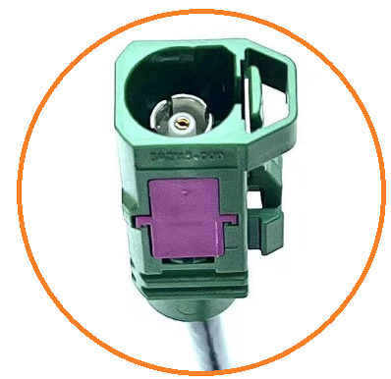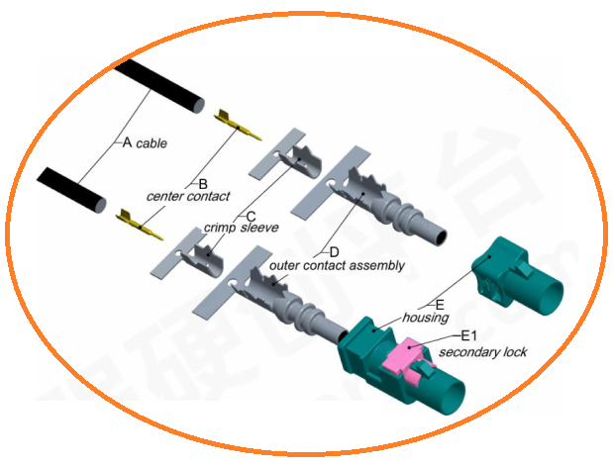

- General Information of Cable Assembly
Feature/Speed | -Primary and secondary locking systems for increased assembly security  -13 mechanical and colored coding with one neutral coding, refer to FAKRA coding on next page  -20 Gbps of data speed for the connected vehicle, supporting any modern radar, camera, lidar or sensor applications
Rated Current | 1A Max
Insulation Resistance | ≥100MΩ
Contact Resistance | ≤5Ω
Operation Temperature | -40℃ ~+105℃
Poles | 1,2,4 Poles are available（Refer to SKU table）
Cable | RG 174, RTK 031, RG59, RG179, RG58/62 etc. (50, 61,75, 93,120 Ohm) options
Rentention Force Latch | ≥ 110 N
Rentention Force Lock | ≥80N (Primary)  ≥60N (Secondary)
Compliant to Standard | Per ISO20860-1 and -2, USCAR17 and 18
Water Resistance Level | No/IPX7/IPX9K in locked condition options
Application | Driving modules, Camera, Antenna, GPS, Gateway/Switch modules, 4K displays, High-speed cable networking, Sensor-device connectivity, surround view cameras,  Infotainment devices

- Dimensions of Related Components (Unit is mm)
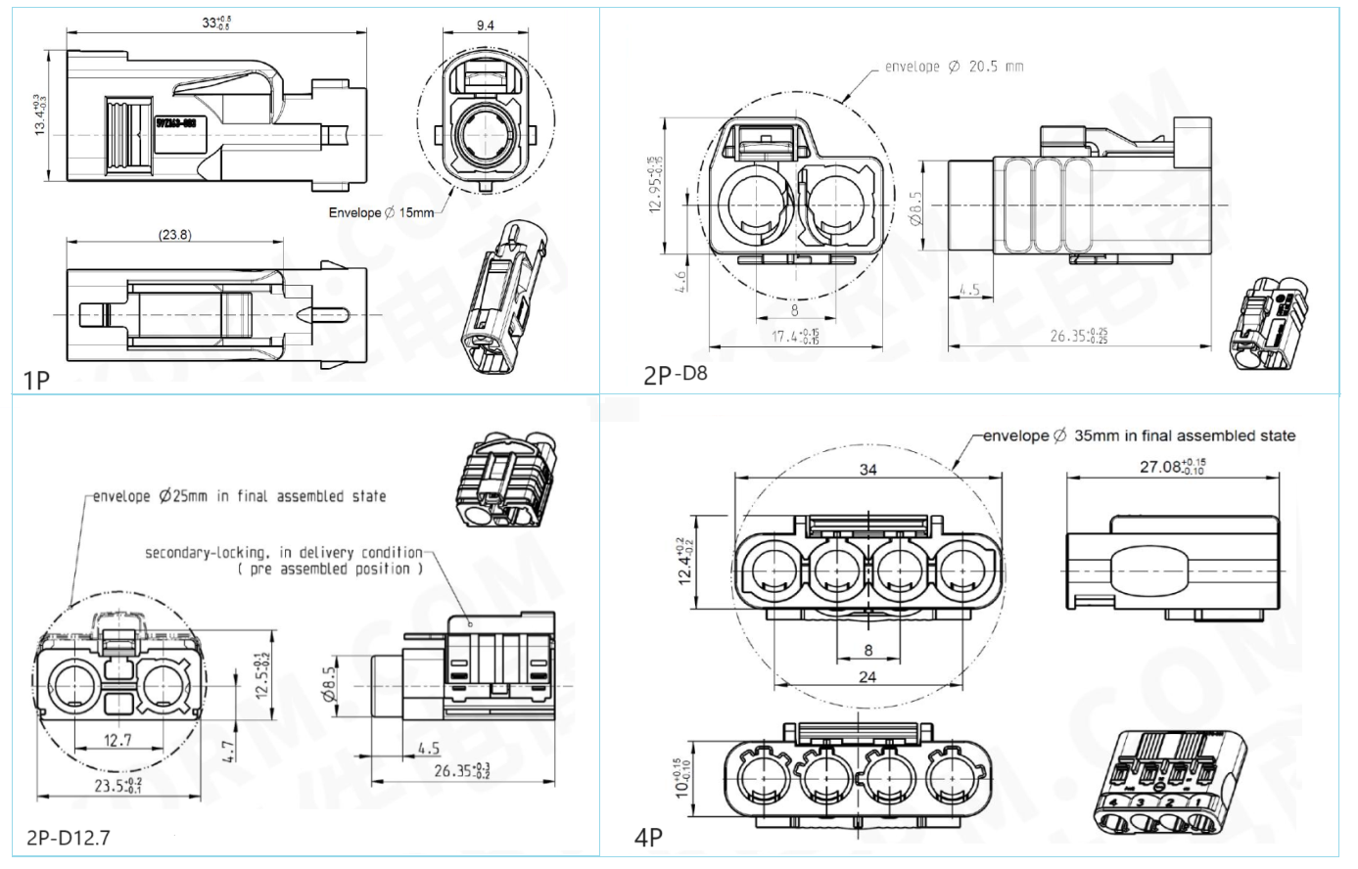
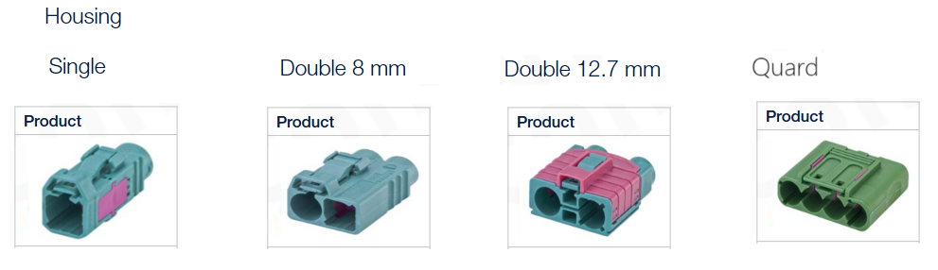

- General Information of Connector
Frequency Range: DC-6GHz Insulation Resistance: 1000MΩ min.
Working Voltage: 335V max. Impedance: 50 Ω Max.
Center Contact Resistance: 20mΩ max. Return Loss: ≥ 18 dB
Dielectric Withstanding Voltage: 1000V min. IP Rating: No/IPX7/IPX9K in locked condition (options)
Temperature Range: -40 °C to +105 °C Housing/Center contact: PBT, PA/CuZn, CuBe, CuSn
V.S.W.R(电压驻波比): 1.3 Max. Mating Endurance: ≥25 Cycles
High Data Rates: Up to 8Gbps
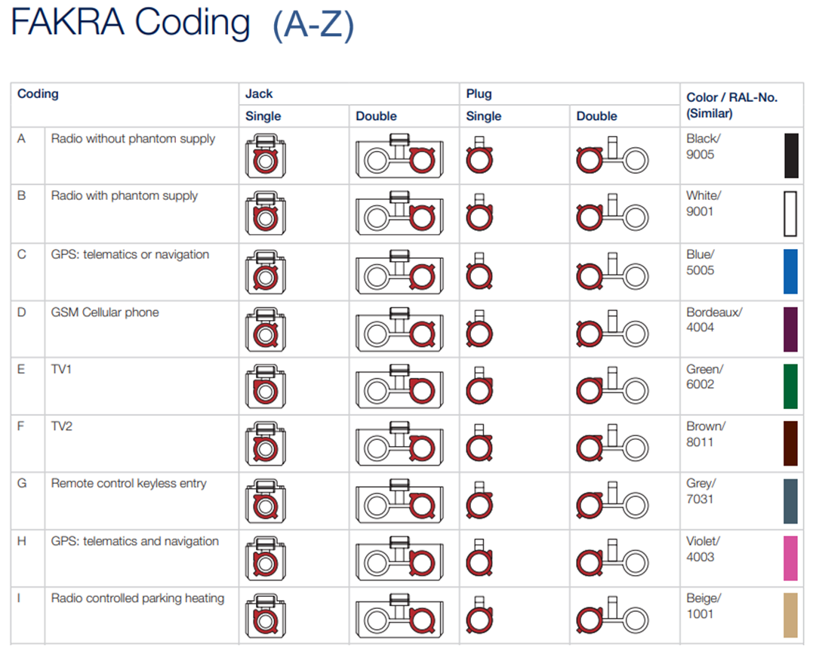
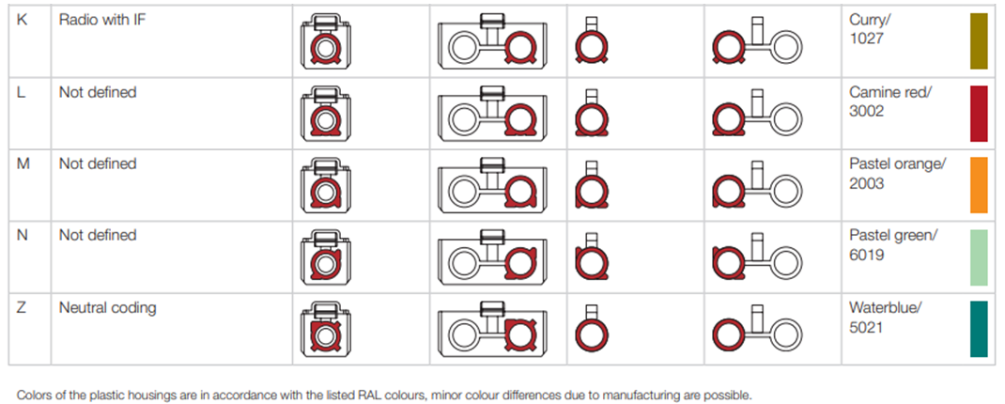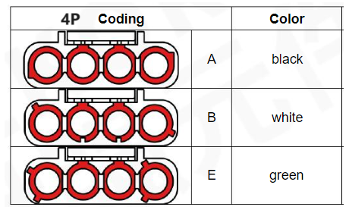
- SKU Table
SKU No. | Poles | Conn. Type | Type | Remark
T-FAKRASTF-01-Coding A-Z | 1 | Female | Straight | Coding A-Z
T-FAKRASTF-02-D8-Coding A-Z | 2 | Female | Straight | Double 8mm type, Coding A-Z
T-FAKRASTF-02-D12.7-Coding A-Z | 2 | Female | Straight | Double 12.7mm type, Coding A-Z
T-FAKRASTF-04-Coding A-Z | 4 | Female | Straight | Coding A-Z

Notes: Coding A-Z color
A Black
B White
C Blue
D Bordeaux violet
E Green
F Brown
G Grey
H Violet
I Beige
K Curry
L Carmin red
M Pastel orange
N Pastel green
Z Water blue

FAKRA Male Connector Cable Assembly, (A Coding to Z Coding)
Product Description
FAKRA (Automated Expert Group) to establish a unified connector system and standards that everyone will follow. Due to its special standard locking system, FAKRA connectors meet the high performance and safety requirements of today's automotive industry.

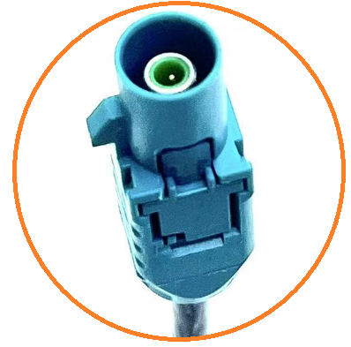

- General Information of Cable Assembly
Feature/Speed | -Primary and secondary locking systems for increased assembly security  -13 mechanical and colored coding with one neutral coding, refer to FAKRA coding on next page  -20 Gbps of data speed for the connected vehicle, supporting any modern radar, camera, lidar or sensor applications
Rated Current | 1A Max
Insulation Resistance | ≥100MΩ
Contact Resistance | ≤5Ω
Operation Temperature | -40℃ ~+105℃
Poles | 1,2 Poles are available（Refer to SKU table）
Cable | RG 174, RTK 031, RG59, RG179, RG58/62 etc. (50, 61,75, 93,120 Ohm) options
Rentention Force Latch | ≥ 110 N
Rentention Force Lock | ≥80N (Primary)  ≥60N (Secondary)
Compliant to Standard | Per ISO20860-1 and -2, USCAR17 and 18
Water Resistance Level | No/IPX7/IPX9K in locked condition options
Application | Driving modules, Camera, Antenna, GPS, Gateway/Switch modules, 4K displays, High-speed cable networking, Sensor-device connectivity, surround view cameras,  Infotainment devices

- Dimensions of Related Components (Unit is mm)
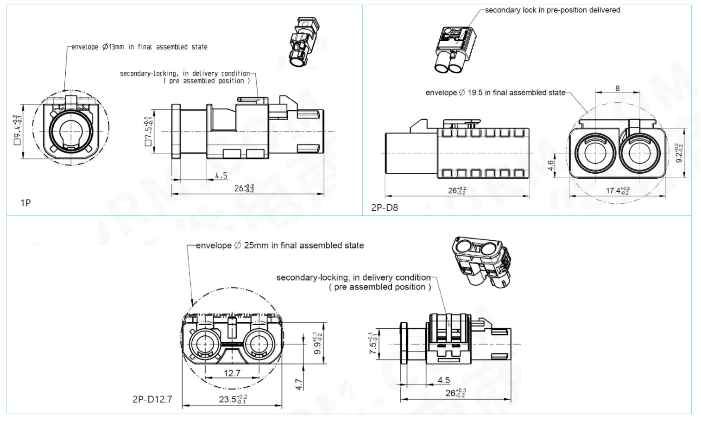
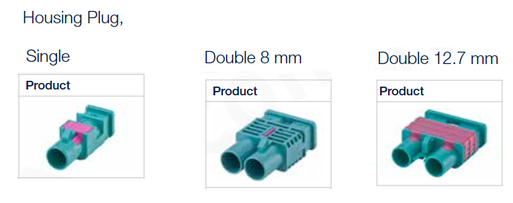
- General Information of Connector
Frequency Range: DC-6GHz Insulation Resistance: 1000MΩ min.
Working Voltage: 335V max. Impedance: 50 Ω Max.
Center Contact Resistance: 20mΩ max. Return Loss: ≥ 18 dB
Dielectric Withstanding Voltage: 1000V min. IP Rating: IPX7/IPX9K in locked condition (options)
Temperature Range: -40 °C to +105 °C Housing/Center contact: PBT, PA/CuZn, CuBe, CuSn
V.S.W.R(电压驻波比): 1.3 Max. Mating Endurance: ≥25 Cycles
High Data Rates: Up to 8Gbps
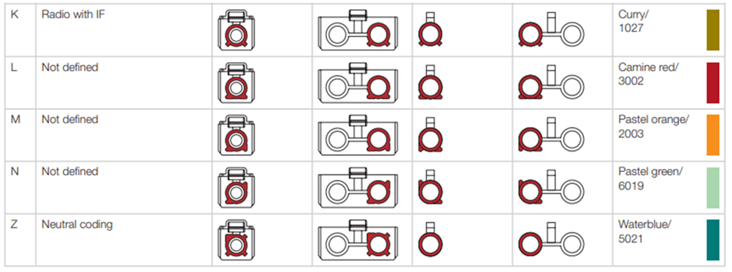

- SKU Table
SKU No. | Poles | Conn. Type | Type | Remark
T-FAKRASTM-01-Coding A-Z | 1 | Male | Straight | Coding A-Z
T-FAKRASTM-02-D8-Coding A-Z | 2 | Male | Straight | Double 8mm type, Coding A-Z
T-FAKRASTM-02-D12.7-Coding A-Z | 2 | Male | Straight | Double 12.7mm type, Coding A-Z

Notes: Coding A-Z color
A Black
B White
C Blue
D Bordeaux violet
E Green
F Brown
G Grey
H Violet
I Beige
K Curry
L Carmin red
M Pastel orange
N Pastel green
Z Water blue

MINI FAKRA Female Connector with Cable Assembly
Product Description
The High-Speed FAKRA Mini Coaxial Cable Solution delivers 20 Gbps of data speed for the connected vehicle, reducing installation space requirements by up to 80 percent compared to traditional FAKRA, supporting any modern radar, camera, lidar or sensor applications.
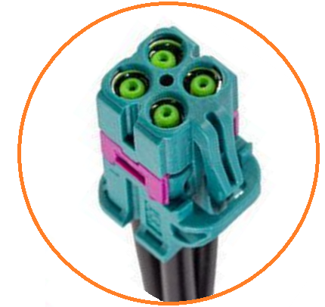

- General Information of Cable Assembly
Feature/Speed | -Primary and secondary locking systems for increased assembly security  -Multiple color-coded enclosures provide visual guidance during assembly and prevent connectors from mismatching with different keyway options.  -20 Gbps of data speed for the connected vehicle, supporting any modern radar, camera, lidar or sensor applications
Rated Current | 1A Max
Rated Voltage | 60V AC/DC
Insulation Resistance | ≥100MΩ
Contact Resistance | ≤5Ω
Operation Temperature | -40℃ ~+105℃
Poles | 1,2,4 Poles are available（Refer to SKU table）
Cable | RG 174, RTK 031, RTK044 etc. (50/75 Ohm) options
Rentention Force Latch | ≥ 110 N
Rentention Force Lock | ≥80N (Primary)  ≥60N (Secondary)

- Dimensions of Related Components (Unit is mm)
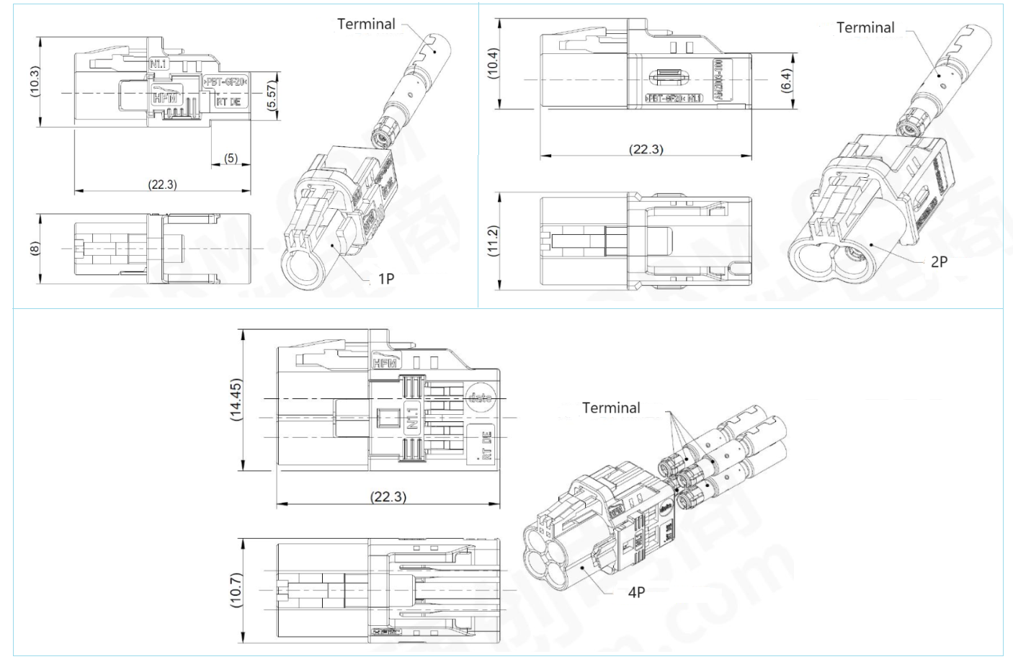

- General Information of Connector
Frequency Range: DC-15GHz Insulation Resistance: 1000MΩ min.
Working Voltage: 335V max. Impedance: 50 Ω Max.
Center Contact Resistance: 15mΩ max. High Data Rates: Up to 8Gbps
Dielectric Withstanding Voltage: 1000V min. Mating Endurance: ≥25 Cycles
Temperature Range: -40 °C to +105 °C Housing/Center contact: PBT-GF
Return Loss: ≥ 25 dB@DC-3GHz, (≥ -20db@3-6GHz, ≥ -12db@6-9GHz)
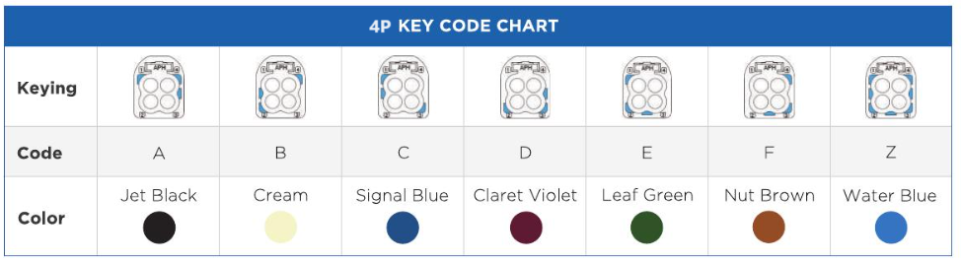
- SKU Table
SKU No. | Poles | Conn. Type | Type | Remark
T-MFAKRASTF-01-Coding A-Z | 1 | Female | Straight | Coding A-Z
T-MFAKRASTF-02-Coding A-Z | 2 | Female | Straight | Coding A-Z
T-MFAKRASTF-04-Coding A-Z | 4 | Female | Straight | Coding A-Z

Notes: Coding A-Z color
A Black
B White
C Blue
D Bordeaux violet
E Green
F Brown
G Grey
H Violet
I Beige
K Curry
L Carmin red
M Pastel orange
N Pastel green
Z Water blue

Energy Storage: 2+12 Pin Molded Cable Assembly, Straight
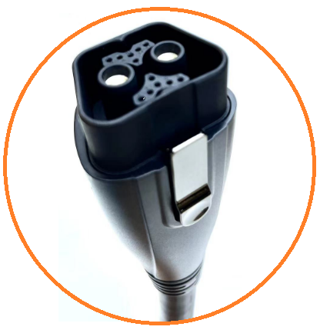

- Dimensions of Cable Assembly (Unit is mm)
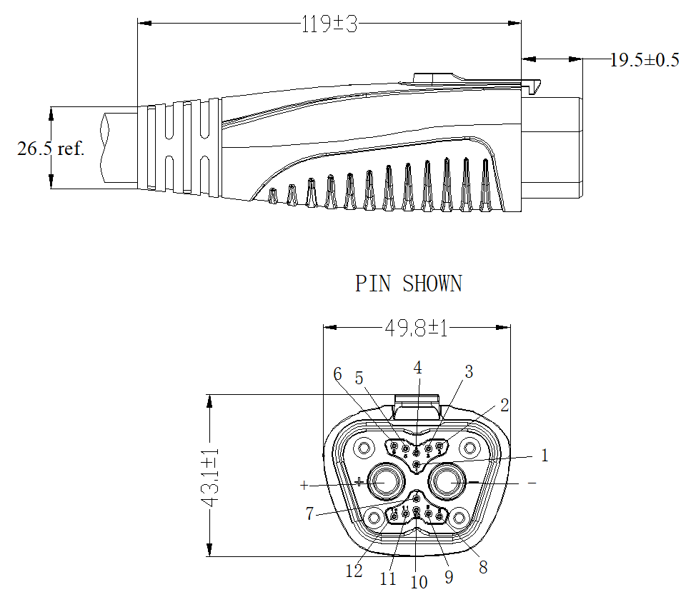

- General Information of Cable Assembly
Rated Current | 100A
Insulation Resistance | ≥100MΩ
Operation Temperature | -40℃ ~+80℃
Poles | 2+12 Pin （Refer to below SKU table）
Water Resistance Level | IP30 in locked condition
Cable | UL2517 2*5AWG+10*22AWG VW-1/FT1, PVC cable
Temperature Rise Test | 120A current lasted for 4H, temperature rise<50K (5AWG/17mm)

- SKU Table
SKU No. | Poles | Conn. Type | Overmoding Type | Remark
T-ESSTF-14-001 | 2+12 | Female | Straight

- Dimensions of Mating Connector (Unit is mm)
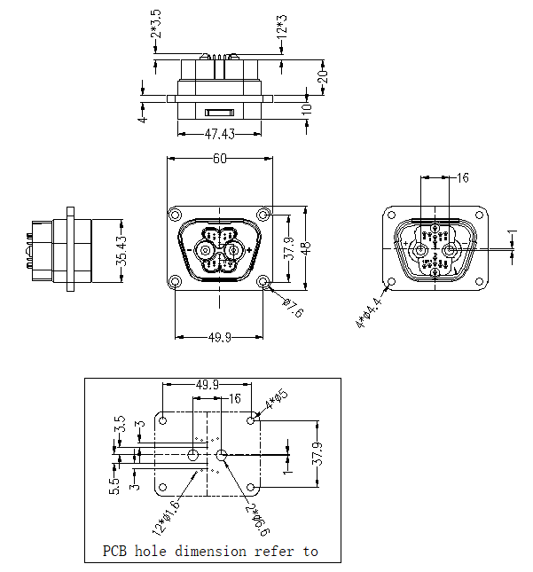

- General Information of Connector

Ambient Temperature: -40℃ ~ +80℃ Insulation Resistance: ≥100MΩ
Connector Body: PA66+GF/94V-0 Insert/Pull Force: <100N
Connector Contacts: Brass with silver plated IP Rating: IP30 in locked condition
Compression Strength: DC500V, leakage current <5mA Mating Endurance: 3000 Cycles

Solar Energy/Photovoltaic: MC4 Female Cable Assembly, Straight
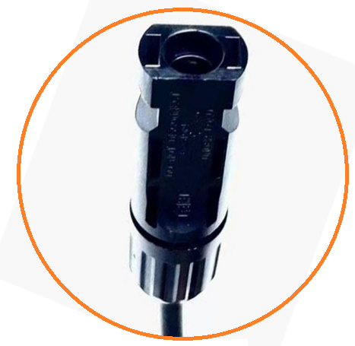

- Dimensions of Cable Assembly (Unit is mm)

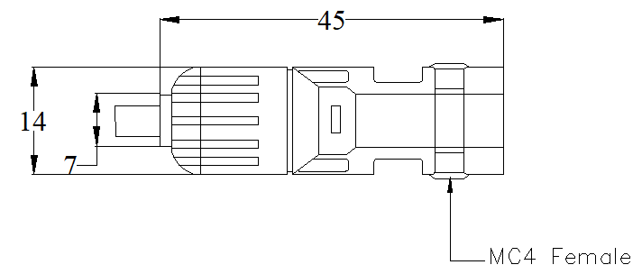

- General Information of Cable Assembly
Rated Current | 30A
Insulation Resistance | ≥100MΩ
Contact Resistance | <0.35mΩ
Operation Temperature | -40℃ ~+80℃
Poles | 1 Pin （Refer to below SKU table）
Water Resistance Level | IP67/IP68 in locked condition, optional
Cable | 16-20AWG VW-1/FT1, PVT or customized

- SKU Table
SKU No. | Poles | Conn. Type | Overmoding Type | Remark
T-MC4STF-01-001 | 1 | Female | Straight

- Dimensions of Related Connector (Unit is mm)
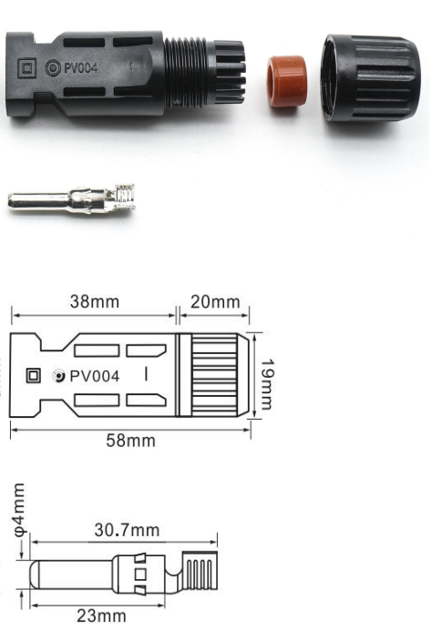

- General Information of Connector

Ambient Temperature: -40℃ ~ +80℃ Insulation Resistance: ≥100MΩ
Connector Body: PA66+GF/94V-0 Insert/Pull Force: <100N
Connector Contacts: Brass with silver plated IP Rating: IP67/IP68 in locked condition optional
Rated Current/Voltage: 30A/1000V

Solar Energy/Photovoltaic: MC4 Male Cable Assembly, Straight
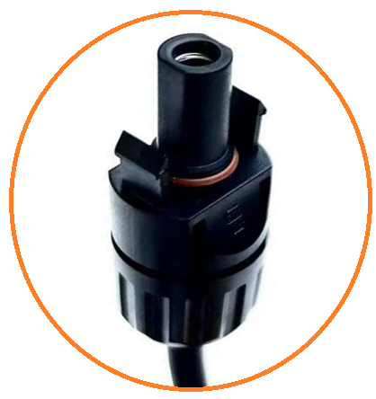

- Dimensions of Cable Assembly (Unit is mm)
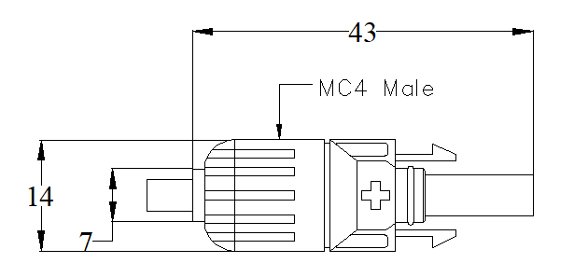

- General Information of Cable Assembly
Rated Current | 30A
Insulation Resistance | ≥100MΩ
Contact Resistance | <0.35mΩ
Operation Temperature | -40℃ ~+80℃
Poles | 1 Pin （Refer to below SKU table）
Water Resistance Level | IP67/IP68 in locked condition, optional
Cable | 16-20AWG VW-1/FT1, PVT or customized

- SKU Table
SKU No. | Poles | Conn. Type | Overmoding Type | Remark
T-MC4STF-01-001 | 1 | Male | Straight

- Dimensions of Related Connector (Unit is mm)
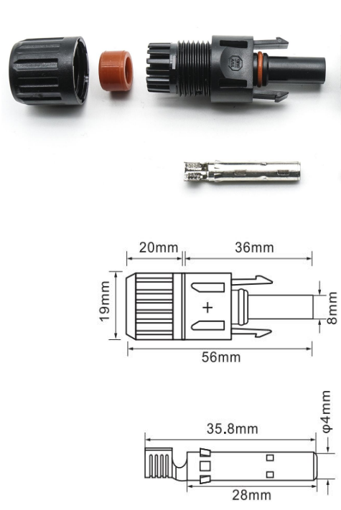

- General Information of Connector

Ambient Temperature: -40℃ ~ +80℃ Insulation Resistance: ≥100MΩ
Connector Body: PA66+GF/94V-0 Insert/Pull Force: <100N
Connector Contacts: Brass with silver plated IP Rating: IP67/IP68 in locked condition optional
Rated Current/Voltage: 30A/1000V

M23 Male Charging/Discharging Battery Connector, Molded Cable Assembly
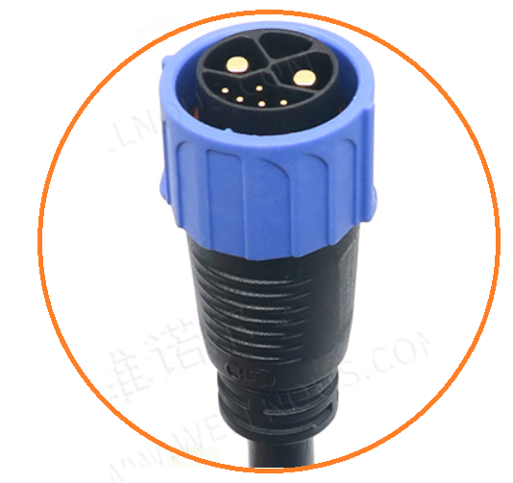

- Dimensions of Cable Assembly (Unit is mm)

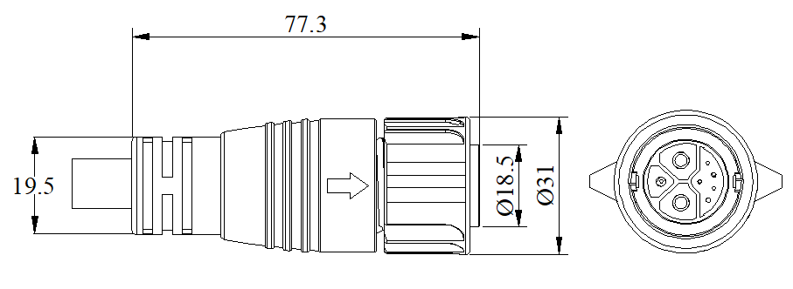

- General Information of Cable Assembly
Rated Current | 50A/10A/3A
Rated Voltage | 500V/300V/60V /DC
Insulation Resistance | ≥100MΩ
Contact Resistance | ≤10 mΩ
Operation Temperature | -40℃ ~+105℃
Poles | 2+0, 2+5, 2+1+3, 2+1+5 Pins Optional (Refer to below SKU table and pin picture）, straight or right angle optional
Water Resistance Level | IP67/IP68 in locked condition, optional
Cable | 8AWG*2C+16AWG*1C+22AWG*5C,PVC or customized

- Difference Pins as Below:
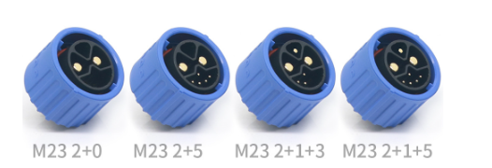
- SKU Table
SKU No. | Poles | Conn. Type | Overmoding Type | Remark
T-EM23STM-2-001 | 2+0 | Male | Straight
T-EM23STM-7-001 | 2+5 | Male | Straight
T-EM23STM-6-001 | 2+1+3 | Male | Straight
T-EM23STM-8-001 | 2+1+5 | Male | Straight
T-EM23RAM-2-001 | 2+0 | Male | Right Angle
T-EM23RAM-7-001 | 2+5 | Male | Right Angle
T-EM23RAM-6-001 | 2+1+3 | Male | Right Angle
T-EM23RAM-8-001 | 2+1+5 | Male | Right Angle

- Dimensions of Related Connector (Unit is mm)
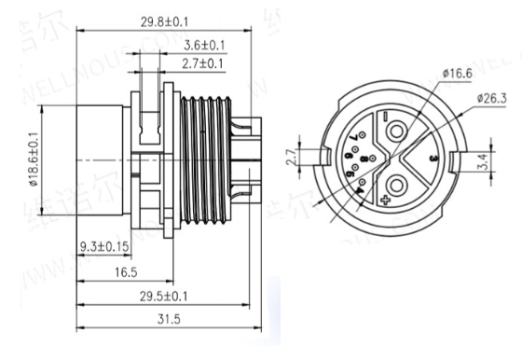

- General Information of Connector

Ambient Temperature: -40℃ ~ +105℃ Insulation Resistance: ≥100MΩ
Connector Body: UL94V-0 Rated Current: 20-50A
Connector Contacts: Brass with silver/golded plated IP Rating: IP67/IP68 in locked condition optional
M23 Male With Base, Charging/Discharging Battery Connector, Cable Assembly

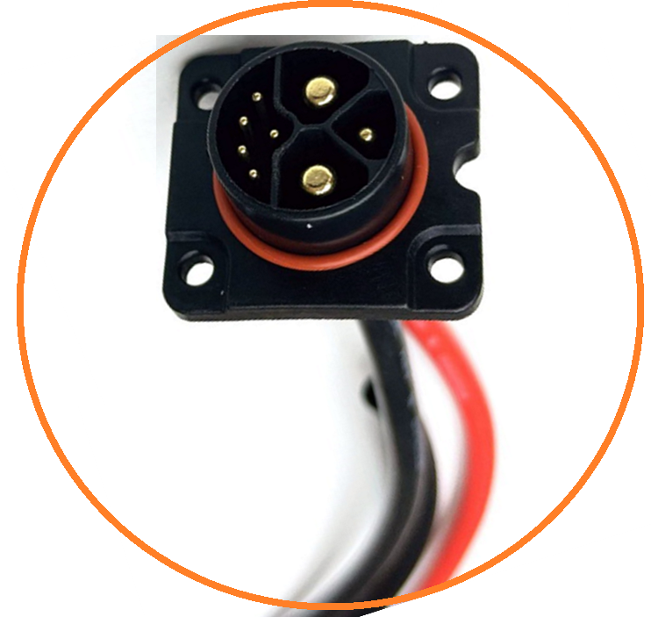

- General Information of Cable Assembly
Rated Current | 50A/10A/3A
Rated Voltage | 500V/300V/60V /DC
Insulation Resistance | ≥100MΩ
Contact Resistance | ≤10 mΩ
Operation Temperature | -40℃ ~+105℃
Poles | 2+1+5 Pins is available (Refer to below SKU table), 2+0, 2+5, 2+1+3 PIN can be customized
Water Resistance Level | IP67/IP68 in locked condition, optional
Cable | 8AWG*2C+16AWG*1C+22AWG*5C,PVC or customized

- SKU Table
SKU No. | Poles | Conn. Type | Type | Remark
T-EM23BM-2-001 | 2+0 | Male | Assembly
T-EM23BM-7-001 | 2+5 | Male | Assembly
T-EM23BM-6-001 | 2+1+3 | Male | Assembly
T-EM23BM-8-001 | 2+1+5 | Male | Assembly

- Dimensions of Related Connector (Unit is mm)

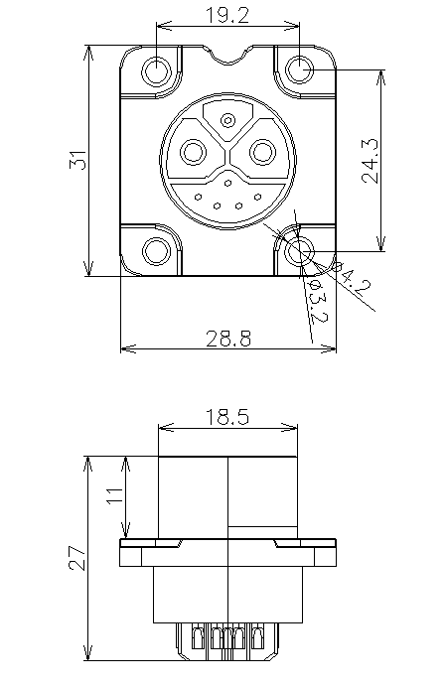

- General Information of Connector

Ambient Temperature: -40℃ ~ +105℃ Insulation Resistance: ≥100MΩ
Connector Body: UL94V-0 Rated Current: 20-50A
Connector Contacts: Brass with silver/golded plated IP Rating: IP67/IP68 in locked condition optional

M23 Female Charging/Discharging Battery Connector, Cable Assembly
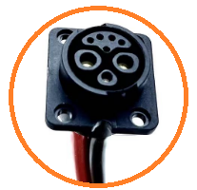

- General Information of Cable Assembly
Rated Current | 50A/10A/3A
Rated Voltage | 500V/300V/60V /DC
Insulation Resistance | ≥100MΩ
Contact Resistance | ≤10 mΩ
Operation Temperature | -40℃ ~+105℃
Poles | 2+0, 2+5, 2+1+3, 2+1+5 Pins Optional (Refer to below SKU table and pin picture）
Water Resistance Level | IP67/IP68 in locked condition, optional
Cable | 8AWG*2C+16AWG*1C+22AWG*5C,PVC or customized

- Difference Pins as Below:
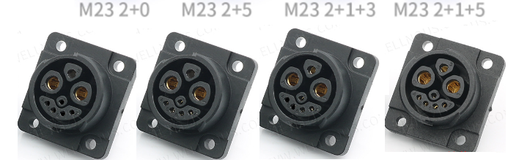
- SKU Table
SKU No. | Poles | Conn. Type | Type | Remark
T-EM23BF-2-001 | 2+0 | Female | Assembly
T-EM23BF-7-001 | 2+5 | Female | Assembly
T-EM23BF-6-001 | 2+1+3 | Female | Assembly
T-EM23BF-8-001 | 2+1+5 | Female | Assembly

- Dimensions of Related Connector (Unit is mm)
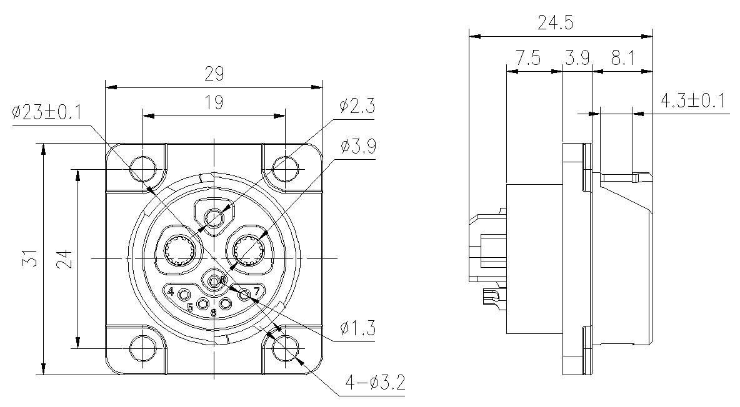

- General Information of Connector

Ambient Temperature: -40℃ ~ +105℃ Insulation Resistance: ≥100MΩ
Connector Body: UL94V-0 Rated Current: 20-50A
Connector Contacts: Brass with silver/golden plated IP Rating: IP67/IP20/IP68 in locked condition optional

Customized, Type C, Female Cable Assembly, IP68
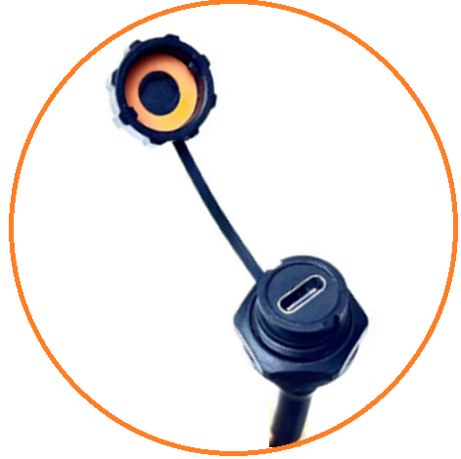

- Dimensions of Cable Assembly (Unit is mm)
- General Information of Cable Assembly
Rated Voltage | 30V /DC
Insulation Resistance | ≥5MΩ
Contact Resistance | ≤3Ω
Water Resistance Level | IP68 in locked condition
Cable | UL2464 22AWG*4C PVC blk, can be customized

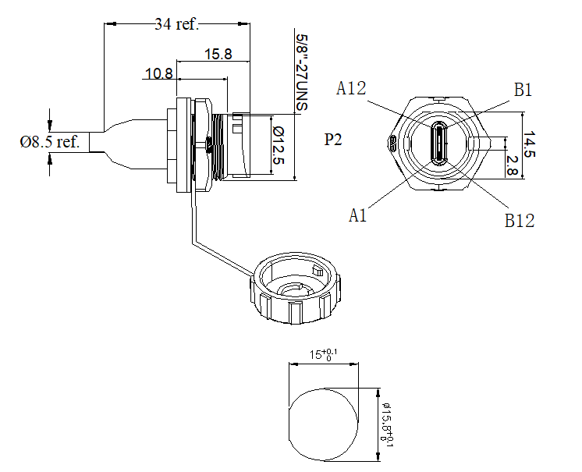
- SKU Table
SKU No. | Poles | Conn. Type | Type | Remark
T-CUSTC4F-002 | 4 | Female | Assembly | Customized

- Dimensions of Related Connector (Unit is mm)

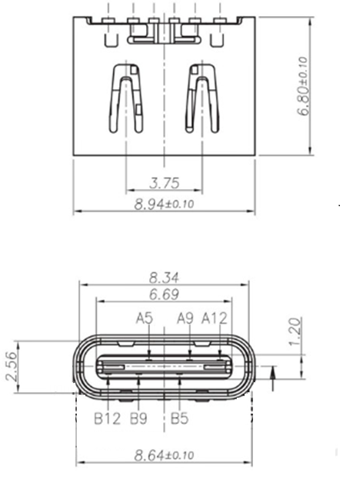

- General Information of Connector

Ambient Temperature: -25℃ ~ +85℃ Insulation Resistance: ≥5MΩ
Connector Body: PBT, black Fire resistance： UL94V-0
Connector Contacts: Brass with silver/golden plated

Customized, 4Pin Male Cable Assembly For Smart System, IP67
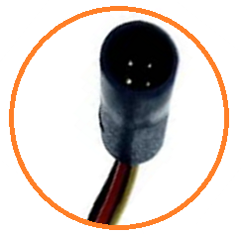

- Dimensions of Cable Assembly (Unit is mm)
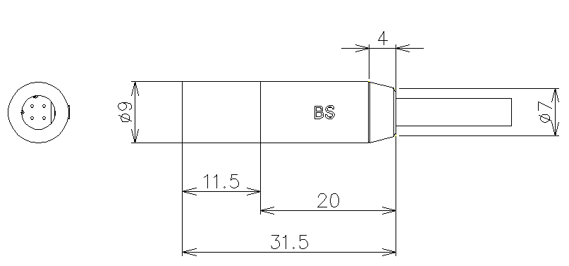

- General Information of Cable Assembly
Rated Voltage | 12V /DC
Insulation Resistance | ≥10MΩ
Contact Resistance | ≤3Ω
Water Resistance Level | IP67 in locked condition
Cable | Cable, length can be customized
Application | - Original Bosch replacement cable, Connects the drive unit with the control unit

- SKU Table
SKU No. | Poles | Conn. Type | Overmold Type | Remark
T-CUS4M-002 | 4 | Male | Straight | Customized

- Dimensions of Related Connector (Unit is mm)

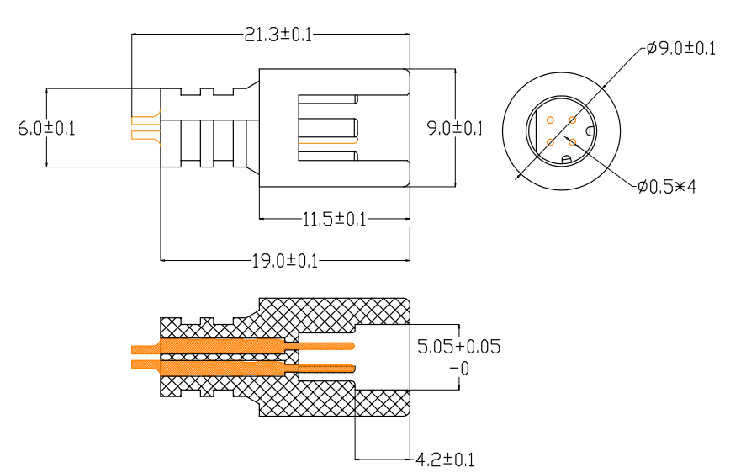

- General Information of Connector

Ambient Temperature: -20℃ ~ +80℃ Insulation Resistance: ≥100MΩ
Connector Body: PA66, black Fire resistance： UL94V-0
Connector Contacts: Brass with golden plated Water Resistance: IP66

Customized, 4Pin Female Cable Assembly For Smart System, IP67
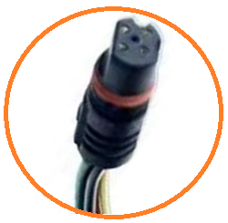

- Dimensions of Cable Assembly (Unit is mm)
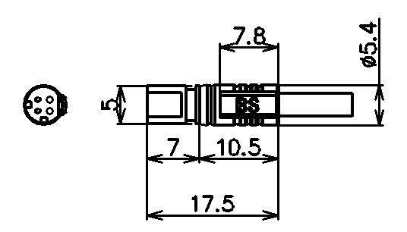

- General Information of Cable Assembly
Rated Voltage | 12V /DC
Insulation Resistance | ≥10MΩ
Contact Resistance | ≤3Ω
Water Resistance Level | IP67 in locked condition
Cable | Cable, length can be customized
Application | - Original Bosch replacement cable, Connects the drive unit with the control unit

- SKU Table
SKU No. | Poles | Conn. Type | Overmold Type | Remark
T-CUS4F-002 | 4 | Female | Straight | Customized

- Dimensions of Related Connector (Unit is mm)

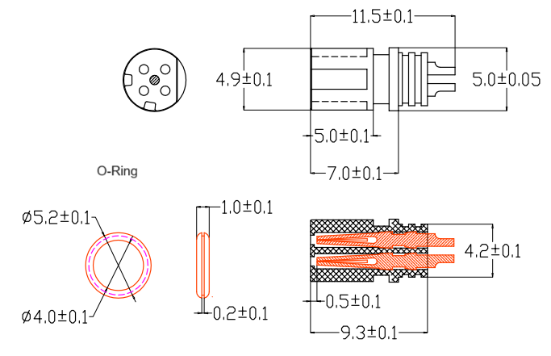

- General Information of Connector

Ambient Temperature: -20℃ ~ +80℃ Insulation Resistance: ≥100MΩ
Connector Body: PA66, black Fire resistance： UL94V-0
Connector Contacts: Brass with golden plated Water Resistance: IP66 vel

CPC 9PIN Female Molded Cable Assembly
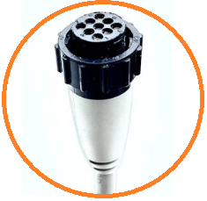

- Dimensions of Cable Assembly (Unit is mm)
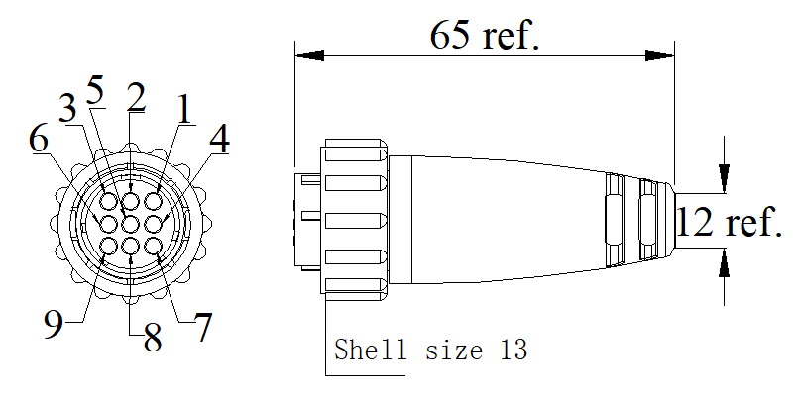

- General Information of Cable Assembly
Rated Current | 13A Max.(Series1); 7.5A Max.(Series2); 25A Max.(Series3);  25A Max.(Series4); 50A Max.(Series5); 50A Max.(Series6);
Insulation Resistance | ≥100MΩ
Contact Resistance | ≤5Ω
Operation Temperature | -20℃ ~+80℃
Poles | 8,17 Poles are available,  3,4,5,12 can be customized （Refer to below SKU table）
Water Resistance Level | IP67, IP68 can be customized (In locked condition)
Cable | PUR/PVC cable options

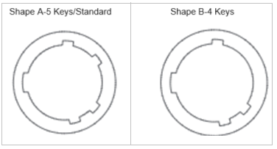
- Shape A and Shape B of Locked Key （Optional）

- Pinouts（Optional for difference CNC connector）
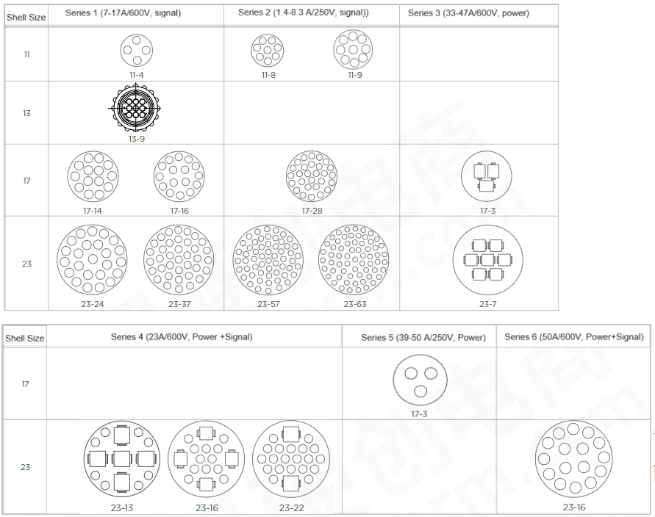
- SKU Table
Assembly SKU No. | Connector Information |  |  |  |  | Cable Assembly
Assembly SKU No. | Poles | Conn. Type | Locked Key | Series | Shell Size | Overmoding or Assembly Type
T-CPCS1STF-5-04-001-Shell 11 | 4 | Female | 5 | 1 | 11 | Customized
T-CPCS1STF-4-04-001-Shell 11 | 4 | Female | 4 | 1 | 11 | Customized
T-CPCS1STF-5-09-001-Shell 13 | 9 | Female | 5 | 1 | 13 | Optional
T-CPCS1STF-4-09-001-Shell 13 | 9 | Female | 4 | 1 | 13 | Optional
T-CPCS1STF-5-14-001-Shell 17 | 14 | Female | 5 | 1 | 17 | Customized
T-CPCS1STF-4-14-001-Shell 17 | 14 | Female | 4 | 1 | 17 | Customized
T-CPCS1STF-5-16-001-Shell 17 | 16 | Female | 5 | 1 | 17 | Customized
T-CPCS1STF-4-16-001-Shell 17 | 16 | Female | 4 | 1 | 17 | Customized
T-CPCS1STF-5-24-001-Shell 23 | 24 | Female | 5 | 1 | 23 | Customized
T-CPCS1STF-4-24-001-Shell 23 | 24 | Female | 4 | 1 | 23 | Customized
T-CPCS1STF-5-37-001-Shell 23 | 37 | Female | 5 | 1 | 23 | Customized
T-CPCS1STF-4-37-001-Shell 23 | 37 | Female | 4 | 1 | 23 | Customized

Assembly SKU No. | Connector Information |  |  |  |  | Cable Assembly
Assembly SKU No. | Poles | Conn. Type | Locked Key | Series | Shell Size | Overmoding or Assembly Type
T-CPCS2STF-5-08-001-Shell 11 | 8 | Female | 5 | 2 | 11 | Customized
T-CPCS2STF-4-08-001-Shell 11 | 8 | Female | 4 | 2 | 11 | Customized
T-CPCS2STF-5-09-001-Shell 11 | 9 | Female | 5 | 2 | 11 | Optional
T-CPCS2STF-4-09-001-Shell 11 | 9 | Female | 4 | 2 | 11 | Optional
T-CPCS2STF-5-28-001-Shell 17 | 28 | Female | 5 | 2 | 17 | Customized
T-CPCS2STF-4-28-001-Shell 17 | 28 | Female | 4 | 2 | 17 | Customized
T-CPCS2STF-5-57-001-Shell 23 | 57 | Female | 5 | 2 | 23 | Customized
T-CPCS2STF-4-57-001-Shell 23 | 57 | Female | 4 | 2 | 23 | Customized
T-CPCS2STF-5-63-001-Shell 23 | 63 | Female | 5 | 2 | 23 | Customized
T-CPCS2STF-4-63-001-Shell 23 | 63 | Female | 4 | 2 | 23 | Customized
T-CPCS3STF-5-3-001-Shell 17 | 3 | Female | 5 | 3 | 17 | Customized
T-CPCS3STF-4-3-001-Shell 17 | 3 | Female | 4 | 3 | 17 | Customized
T-CPCS3STF-5-7-001-Shell 23 | 7 | Female | 5 | 3 | 23 | Customized
T-CPCS3STF-4-7-001-Shell 23 | 7 | Female | 4 | 3 | 23 | Customized
T-CPCS4STF-5-13-001-Shell 23 | 13 | Female | 5 | 4 | 23 | Customized
T-CPCS4STF-4-13-001-Shell 23 | 13 | Female | 4 | 4 | 23 | Customized
T-CPCS4STF-5-16-001-Shell 23 | 16 | Female | 5 | 4 | 23 | Customized
T-CPCS4STF-4-16-001-Shell 23 | 16 | Female | 4 | 4 | 23 | Customized
T-CPCS4STF-5-22-001-Shell 23 | 22 | Female | 5 | 4 | 23 | Customized
T-CPCS4STF-4-22-001-Shell 23 | 22 | Female | 4 | 4 | 23 | Customized
T-CPCS5STF-5-3-001-Shell 17 | 3 | Female | 5 | 5 | 17 | Customized
T-CPCS5STF-4-3-001-Shell 17 | 3 | Female | 4 | 5 | 17 | Customized
T-CPCS6STF-5-16-001-Shell 23 | 16 | Female | 5 | 6 | 23 | Customized
T-CPCS6STF-4-16-001-Shell 23 | 16 | Female | 4 | 6 | 23 | Customized

- Dimensions of Related Components (Unit is inch)
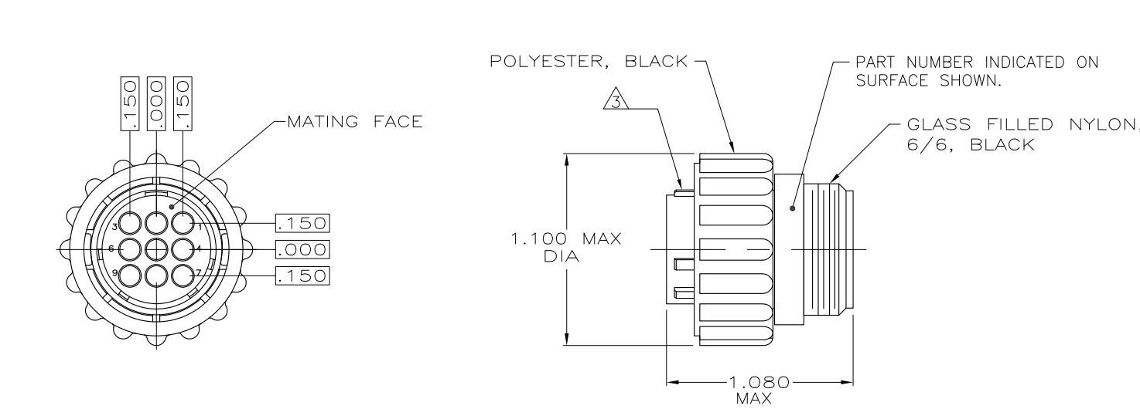
- General Information of Connector

Ambient Temperature: -55℃ ~ +105℃ Insulation Resistance: ≥100MΩ
Connector Body: Glass filled nylon 6/6,black IP Rating: IP65,IP67 optional
Connector Contacts: Brass with gold plated
- CPC Series Information of Connector
Items | Description | Contact Shape
Series 1 | Standard, Terminal OD with 1.57mm, 13A Max, 4-37P | 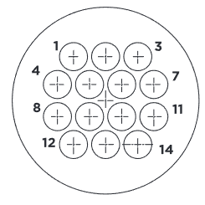
Series 2 | High Density, Terminal OD with 1.02mm, 7.5A Max, 8-63P | 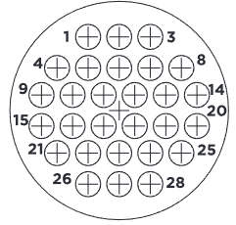
Series 3 | Power Density, 25A Max., 13P, 16P, 22P | 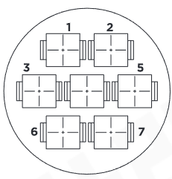
Series 4 | Power and Signal combine, Signal 13A max.; Power 25A Max., 13P, 16P, 22P | 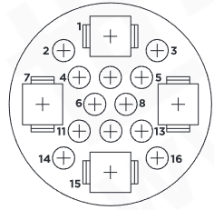
Series 5 | Power Density (Seal IP65/67 optional), Power with 50A Max., with 3x Powerband | 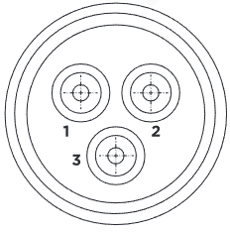
Series 6 | Power and Signal combine (Seal optional), Signal 13A max., Power 50A Max., with 2x powerband and 8x III+ signal contact | 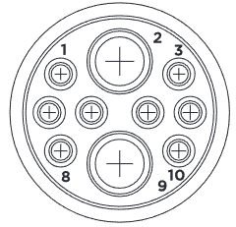

CPC 9PIN Male Molded Cable Assembly
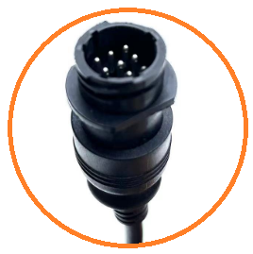

- Dimensions of Cable Assembly (Unit is mm)

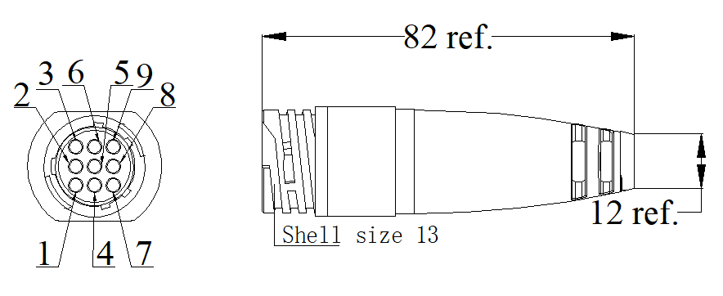

- General Information of Cable Assembly
Rated Current | 13A Max.(Series1); 7.5A Max.(Series2); 25A Max.(Series3);  25A Max.(Series4); 50A Max.(Series5); 50A Max.(Series6);
Insulation Resistance | ≥100MΩ
Contact Resistance | ≤5Ω
Operation Temperature | -20℃ ~+80℃
Poles | 8,17 Poles are available,  3,4,5,12 can be customized （Refer to below SKU table）
Water Resistance Level | IP67, IP68 can be customized ( in locked condition)
Cable | PUR/PVC cable options

- Shape A and Shape B of Locked Key （Optional）

- Pinouts（Optional for difference CNC connector）
- SKU Table
Assembly SKU No. | Connector Information |  |  |  |  | Cable Assembly
Assembly SKU No. | Poles | Conn. Type | Locked Key | Series | Shell Size | Overmoding or Assembly Type
T-CPCS1STM-5-04-001-Shell 11 | 4 | Male | 5 | 1 | 11 | Customized
T-CPCS1STM-4-04-001-Shell 11 | 4 | Male | 4 | 1 | 11 | Customized
T-CPCS1STM-5-09-001-Shell 13 | 9 | Male | 5 | 1 | 13 | Optional
T-CPCS1STM-4-09-001-Shell 13 | 9 | Male | 4 | 1 | 13 | Optional
T-CPCS1STM-5-14-001-Shell 17 | 14 | Male | 5 | 1 | 17 | Customized
T-CPCS1STM-4-14-001-Shell 17 | 14 | Male | 4 | 1 | 17 | Customized
T-CPCS1STM-5-16-001-Shell 17 | 16 | Male | 5 | 1 | 17 | Customized
T-CPCS1STM-4-16-001-Shell 17 | 16 | Male | 4 | 1 | 17 | Customized
T-CPCS1STM-5-24-001-Shell 23 | 24 | Male | 5 | 1 | 23 | Customized
T-CPCS1STM-4-24-001-Shell 23 | 24 | Male | 4 | 1 | 23 | Customized
T-CPCS1STM-5-37-001-Shell 23 | 37 | Male | 5 | 1 | 23 | Customized
T-CPCS1STM-4-37-001-Shell 23 | 37 | Male | 4 | 1 | 23 | Customized

Assembly SKU No. | Connector Information |  |  |  |  | Cable Assembly
Assembly SKU No. | Poles | Conn. Type | Locked Key | Series | Shell Size | Overmoding or Assembly Type
T-CPCS2STM-5-08-001-Shell 11 | 8 | Male | 5 | 2 | 11 | Customized
T-CPCS2STM-4-08-001-Shell 11 | 8 | Male | 4 | 2 | 11 | Customized
T-CPCS2STM-5-09-001-Shell 11 | 9 | Male | 5 | 2 | 11 | Optional
T-CPCS2STM-4-09-001-Shell 11 | 9 | Male | 4 | 2 | 11 | Optional
T-CPCS2STM-5-28-001-Shell 17 | 28 | Male | 5 | 2 | 17 | Customized
T-CPCS2STM-4-28-001-Shell 17 | 28 | Male | 4 | 2 | 17 | Customized
T-CPCS2STM-5-57-001-Shell 23 | 57 | Male | 5 | 2 | 23 | Customized
T-CPCS2STM-4-57-001-Shell 23 | 57 | Male | 4 | 2 | 23 | Customized
T-CPCS2STM-5-63-001-Shell 23 | 63 | Male | 5 | 2 | 23 | Customized
T-CPCS2STM-4-63-001-Shell 23 | 63 | Male | 4 | 2 | 23 | Customized
T-CPCS3STM-5-3-001-Shell 17 | 3 | Male | 5 | 3 | 17 | Customized
T-CPCS3STM-4-3-001-Shell 17 | 3 | Male | 4 | 3 | 17 | Customized
T-CPCS3STM-5-7-001-Shell 23 | 7 | Male | 5 | 3 | 23 | Customized
T-CPCS3STM-4-7-001-Shell 23 | 7 | Male | 4 | 3 | 23 | Customized
T-CPCS4STM-5-13-001-Shell 23 | 13 | Male | 5 | 4 | 23 | Customized
T-CPCS4STM-4-13-001-Shell 23 | 13 | Male | 4 | 4 | 23 | Customized
T-CPCS4STM-5-16-001-Shell 23 | 16 | Male | 5 | 4 | 23 | Customized
T-CPCS4STM-4-16-001-Shell 23 | 16 | Male | 4 | 4 | 23 | Customized
T-CPCS4STM-5-22-001-Shell 23 | 22 | Male | 5 | 4 | 23 | Customized
T-CPCS4STM-4-22-001-Shell 23 | 22 | Male | 4 | 4 | 23 | Customized
T-CPCS5STM-5-3-001-Shell 17 | 3 | Male | 5 | 5 | 17 | Customized
T-CPCS5STM-4-3-001-Shell 17 | 3 | Male | 4 | 5 | 17 | Customized
T-CPCS6STM-5-16-001-Shell 23 | 16 | Male | 5 | 6 | 23 | Customized
T-CPCS6STM-4-16-001-Shell 23 | 16 | Male | 4 | 6 | 23 | Customized

- Dimensions of Related Components (Unit is mm/inch)
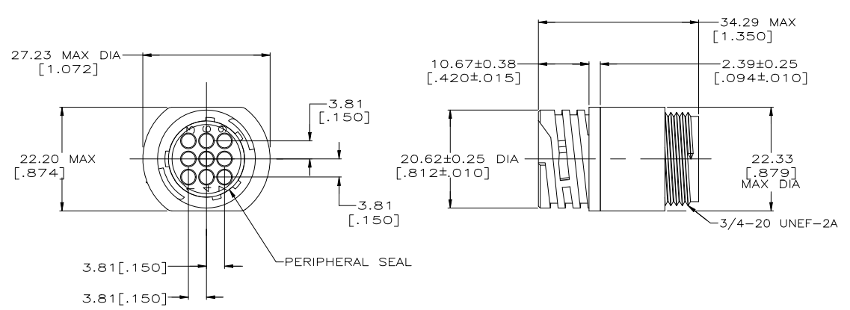
- General Information of Connector

Ambient Temperature: -55℃ ~ +105℃ Insulation Resistance: ≥100MΩ
Connector Body: Glass filled nylon 6/6,black IP Rating: IP65,IP67 optional
Connector Contacts: Brass with gold plated
- CPC Series Information of Connector
Items | Description | Contact Shape
Series 1 | Standard, Terminal OD with 1.57mm, 13A Max, 4-37P
Series 2 | High Density, Terminal OD with 1.02mm, 7.5A Max, 8-63P
Series 3 | Power Density, 25A Max., 13P, 16P, 22P
Series 4 | Power and Signal combine, Signal 13A max.; Power 25A Max., 13P, 16P, 22P
Series 5 | Power Density (Seal IP65/67 optional), Power with 50A Max., with 3x Powerband
Series 6 | Power and Signal combine (Seal optional), Signal 13A max., Power 50A Max., with 2x powerband and 8x III+ signal contact

- SKU Table
SKU No. | Poles | Conn. Type | Overmoding Type | Remark
T-M12ASTM-03-001 | 3 | Male | Straight | With Metal Nut/Screw thread
T-M12ASTM-04-001 | 4 | Male | Straight | With Metal Nut/Screw thread
T-M12ASTM-05-001 | 5 | Male | Straight | With Metal Nut/Screw thread
T-M12ASTM-08-001 | 8 | Male | Straight | With Metal Nut/Screw thread
T-M12ASTM-12-001 | 12 | Male | Straight | With Metal Nut/Screw thread
T-M12ASTM-17-001 | 17 | Male | Straight | With Metal Nut/Screw thread

M12 Female (A Coding) Molded Cable, Straight, With Metal Nut (Screw Thread)
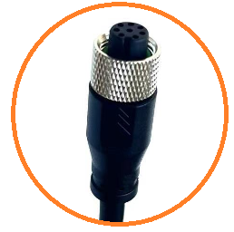

- Dimensions of Cable Assembly (Unit is mm)
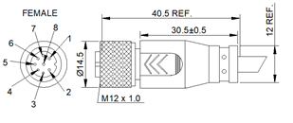

- General Information of Cable Assembly
Rated Current | 2A Max (6-8Pins), 4A Max (2-5Pins), 1.5A Max. (9-17Pins)
Rated Voltage | 30/60V DC
Insulation Resistance | ≥100MΩ
Contact Resistance | ≤5Ω
Operation Temperature | -20℃ ~+80℃
Poles | 4, 8,12 Poles are available,  3,5,17 can be customized （Refer to below SKU table）
Water Resistance Level | IP67, IP68 in locked condition
Cable | PUR/PVC cable (22-28AWG) options

- Pins Layout

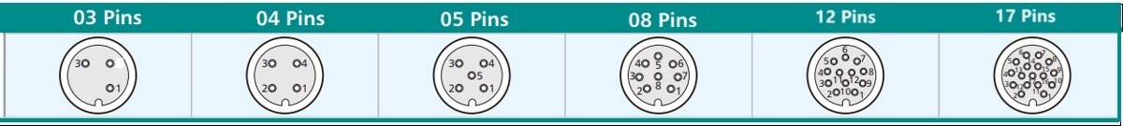

- SKU Table
SKU No. | Poles | Conn. Type | Overmoding Type | Remark
T-M12ASTF-03-001 | 3 | Female | Straight | With Metal Nut/Screw thread
T-M12ASTF-04-001 | 4 | Female | Straight | With Metal Nut/Screw thread
T-M12ASTF-05-001 | 5 | Female | Straight | With Metal Nut/Screw thread
T-M12ASTF-08-001 | 8 | Female | Straight | With Metal Nut/Screw thread
T-M12ASTF-12-001 | 12 | Female | Straight | With Metal Nut/Screw thread
T-M12ASTF-17-001 | 17 | Female | Straight | With Metal Nut/Screw thread

- Dimensions of Related Components (Unit is mm)
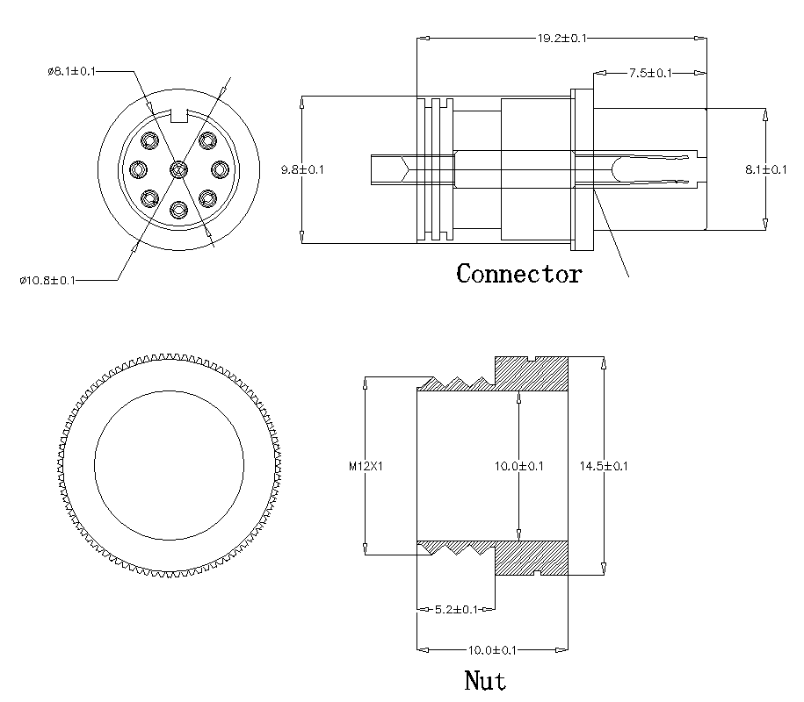

- General Information of Connector

Ambient Temperature: -20℃ ~ +80℃ Insulation Resistance: ≥100MΩ
Connector Body: PA66 Contact Resistance: ≤10mΩ
Connector Contacts: Brass with gold plated Shield: Available
Coupling Nut/Screw: Zinc alloy with nickel plated IP Rating: IP67,IP68 in locked condition
Seal/O-ring: Silicone Mating Endurance: >500 Cycles

M12 Male (A Coding) Molded Cable, Straight, With Metal Nut (Screw Thread)
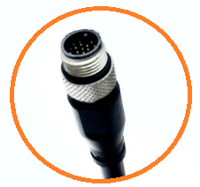

- Dimensions of Cable Assembly (Unit is mm)

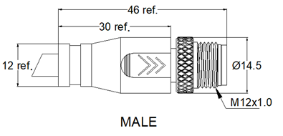

- General Information of Cable Assembly
Rated Current | 2A Max (6-8Pins), 4A Max (2-5Pins), 1.5A Max. (9-17Pins)
Rated Voltage | 30/60V DC
Insulation Resistance | ≥100MΩ
Contact Resistance | ≤5Ω
Operation Temperature | -20℃ ~+80℃
Poles | 8,17 Poles are available,  3,4,5,12 can be customized （Refer to below SKU table）
Water Resistance Level | IP67, IP68 in locked condition
Cable | PUR/PVC cable (22-28AWG) options

- Pins Layout

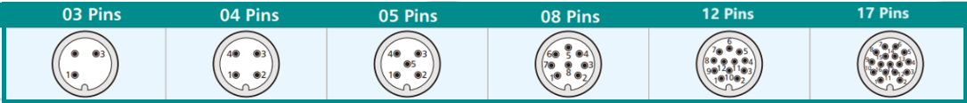

- SKU Table
SKU No. | Poles | Conn. Type | Overmoding Type | Remark
T-M12ASTM-03-001 | 3 | Male | Straight | With Metal Nut/Screw thread
T-M12ASTM-04-001 | 4 | Male | Straight | With Metal Nut/Screw thread
T-M12ASTM-05-001 | 5 | Male | Straight | With Metal Nut/Screw thread
T-M12ASTM-08-001 | 8 | Male | Straight | With Metal Nut/Screw thread
T-M12ASTM-12-001 | 12 | Male | Straight | With Metal Nut/Screw thread
T-M12ASTM-17-001 | 17 | Male | Straight | With Metal Nut/Screw thread

- The Dimensions of Related Components (Unit is mm)
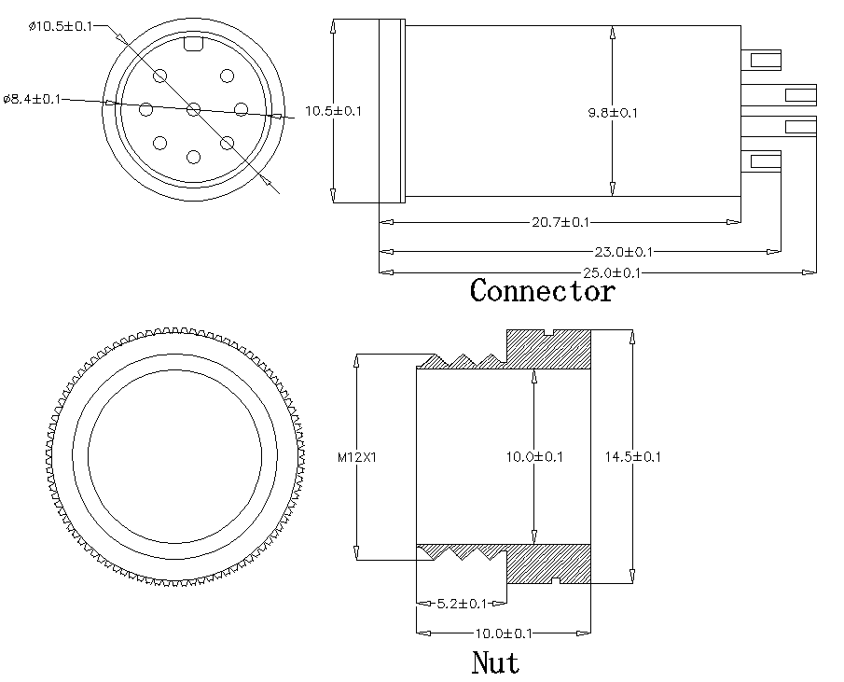

- General Information of Connector
Ambient Temperature: -20℃ ~ +80℃ Insulation Resistance: ≥100MΩ
Connector Body: PA66 Contact Resistance: ≤10mΩ
Connector Contacts: Brass with gold plated Shield: Available
Coupling Nut/Screw: Zinc alloy with nickel plated IP Rating: IP67,IP68 in locked condition
Mating Endurance: >500 Cycles

M12 Female (A Coding) Molded Cable, Right Angle, With Metal Nut (Screw Thread)
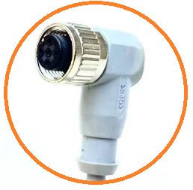

- Dimensions of Cable Assembly (Unit is mm)

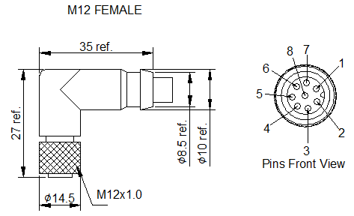

- General Information of Cable Assembly
Rated Current | 2A Max (6-8Pins), 4A Max (2-5Pins), 1.5A Max. (9-17Pins)
Rated Voltage | 30/60V DC
Insulation Resistance | ≥100MΩ
Contact Resistance | ≤5Ω
Operation Temperature | -20℃ ~+80℃
Poles | 5,8 Poles are available,  3,4,12,17 can be customized （Refer to below SKU table）
Water Resistance Level | IP67, IP68 in locked condition
Cable | PUR/PVC cable (22-28AWG) options

- Pins Layout

- SKU Table
SKU No. | Poles | Conn. Type | Overmoding Type | Remark
T-M12ARAF-03-001 | 3 | Female | Right Angle | With Metal Nut/Screw thread
T-M12ARAF-04-001 | 4 | Female | Right Angle | With Metal Nut/Screw thread
T-M12ARAF-05-001 | 5 | Female | Right Angle | With Metal Nut/Screw thread
T-M12ARAF-08-001 | 8 | Female | Right Angle | With Metal Nut/Screw thread
T-M12ARAF-12-001 | 12 | Female | Right Angle | With Metal Nut/Screw thread
T-M12ARAF-17-001 | 17 | Female | Right Angle | With Metal Nut/Screw thread

- Dimensions of Related Components (Unit is mm)
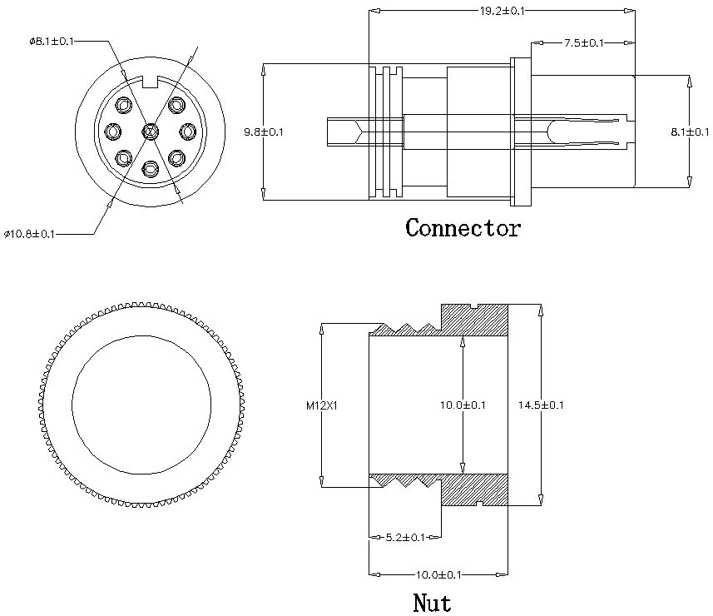
- General Information of Connector

Ambient Temperature: -20℃ ~ +80℃ Insulation Resistance: ≥100MΩ
Connector Body: PA66 Contact Resistance: ≤10mΩ
Connector Contacts: Brass with gold plated Shield: Available
Coupling Nut/Screw: Zinc alloy with nickel plated IP Rating: IP67,IP68 in locked condition
Seal/O-ring: Silicone Mating Endurance: >500 Cycles

M12 Male (A Coding) Molded Cable, Right Angle, With Metal Nut (Screw Thread)
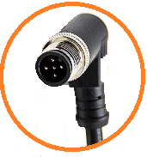

- Dimensions of Cable Assembly (Unit is mm)
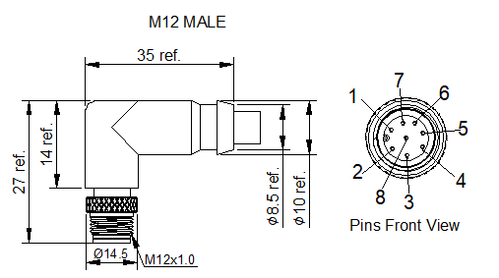

- General Information of Cable Assembly
Rated Current | 2A Max (6-8Pins), 4A Max (2-5Pins), 1.5A Max. (9-17Pins)
Rated Voltage | 30/60V DC
Insulation Resistance | ≥100MΩ
Contact Resistance | ≤5Ω
Operation Temperature | -20℃ ~+80℃
Poles | 3,4,5,8,12,17 can be customized （Refer to below SKU table）
Water Resistance Level | IP67, IP68 in locked condition
Cable | PUR/PVC cable (22-28AWG) options

- Pins Layout

- SKU Table
SKU No. | Poles | Conn. Type | Overmoding Type | Remark
T-M12ARAM-03-001 | 3 | Male | Right Angle | With Metal Nut/Screw thread
T-M12ARAM-04-001 | 4 | Male | Right Angle | With Metal Nut/Screw thread
T-M12ARAM-05-001 | 5 | Male | Right Angle | With Metal Nut/Screw thread
T-M12ARAM-08-001 | 8 | Male | Right Angle | With Metal Nut/Screw thread
T-M12ARAM-12-001 | 12 | Male | Right Angle | With Metal Nut/Screw thread
T-M12ARAM-17-001 | 17 | Male | Right Angle | With Metal Nut/Screw thread

- Dimensions of Related Components (Unit is mm)
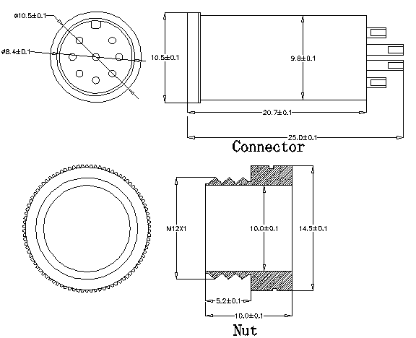

- General Information of Connector

Ambient Temperature: -20℃ ~ +80℃ Insulation Resistance: ≥100MΩ
Connector Body: PA66 Contact Resistance: ≤10mΩ
Connector Contacts: Brass with gold plated Shield: Available
Coupling Nut/Screw: Zinc alloy with nickel plated IP Rating: IP67,IP68 in locked condition
Mating Endurance: >500 Cycles

M12 Male (D Coding) Molded Cable, Straight, With Metal Nut (Screw Thread)
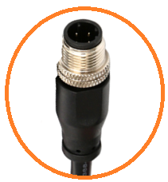

- Dimensions of Cable Assembly (Unit is mm)

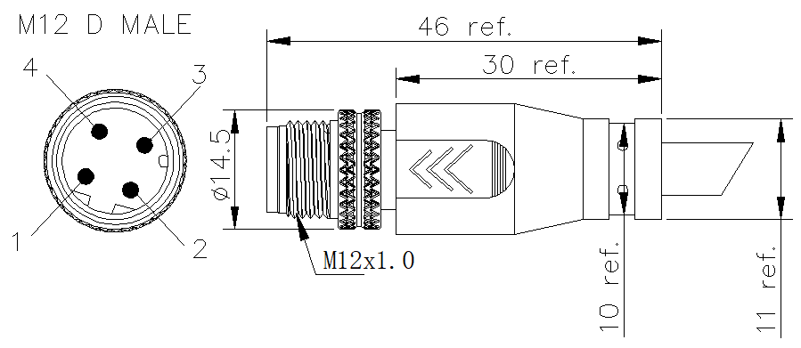

- General Information of Cable Assembly
Rated Current | 4A Max.
Rated Voltage | 30V/60V DC
Insulation Resistance | ≥100MΩ
Contact Resistance | ≤5Ω
Operation Temperature | -20℃ ~+80℃
Poles | 4 Poles straight are available, right angle can be customized (refer to SKU Table)
Water Resistance Level | IP67 in locked condition, IP68 Can be customized
Cable | PUR/PVC cable (18-24AWG) options

- SKU Table
SKU No. | Poles | Conn. Type | Overmoding Type | Remark
T-M12DSTM-04-001 | 4 | Male | Straight | With Metal Nut/Screw thread
T-M12DRAM-04-001 | 4 | Male | Right angle | With Metal Nut/Screw thread

- Dimensions of Related Components (Unit is mm)

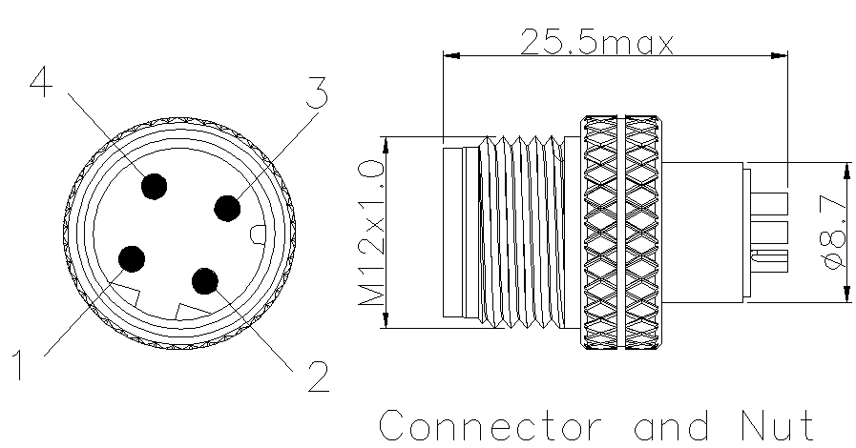

- General Information of Connector

Ambient Temperature: -25℃ ~ +80℃ Insulation Resistance: ≥100MΩ
Connector Body: PA66 Contact Resistance: ≤10mΩ
Connector Contacts: Brass with gold plated Shield: Available
Coupling Nut/Screw: Zinc alloy with nickel plated IP Rating: IP67 in locked condition
Mating Endurance: >500 Cycles

M12 Female (D Coding) Molded Cable, Straight, With Metal Nut (Screw Thread)
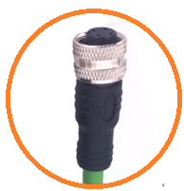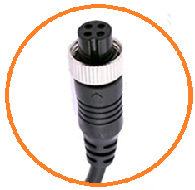

- Dimensions of Cable Assembly (Unit is mm)

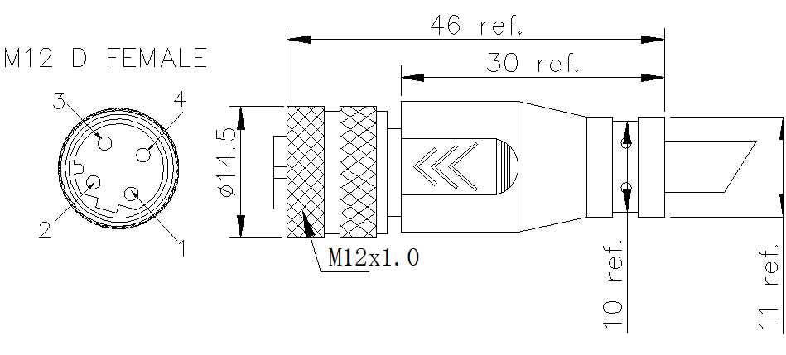

- SKU Table
SKU No. | Poles | Conn. Type | Overmoding Type | Remark
T-M12DSTF-04-001 | 4 | Female | Straight | With Metal Nut/Screw thread
T-M12DRAF-04-001 | 4 | Female | Right angle | With Metal Nut/Screw thread

- General Information of Cable Assembly
Rated Current | 4A Max.
Rated Voltage | 30V/60V DC
Insulation Resistance | ≥100MΩ
Contact Resistance | ≤5Ω
Operation Temperature | -20℃ ~+80℃
Poles | 4 Poles straight are available, right angle can be customized (refer to SKU Table)
Water Resistance Level | IP67 in locked condition, IP68 Can be customized
Cable | PUR/PVC cable (18-24AWG) options

- Dimensions of Related Components (Unit is mm)

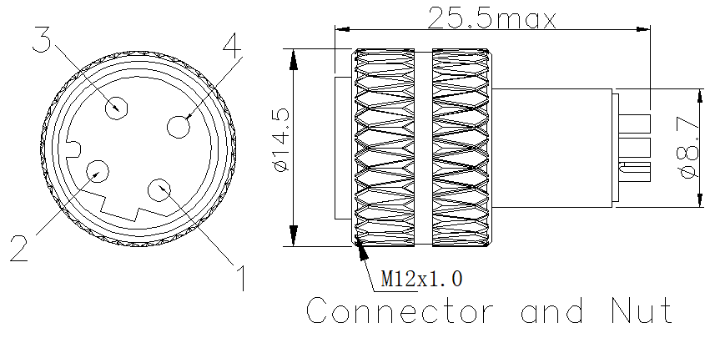

- General Information of Connector

Ambient Temperature: -25℃ ~ +80℃ Insulation Resistance: ≥100MΩ
Connector Body: PA66 Contact Resistance: ≤10mΩ
Connector Contacts: Brass with gold plated Shield: Available
Coupling Nut/Screw: Zinc alloy with nickel plated IP Rating: IP67 in locked condition
Mating Endurance: >500 Cycles

M12 Male (X Coding) Molded Cable, Straight, With Metal Nut (Screw Thread)
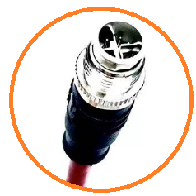

- Dimensions of Cable Assembly (Unit is mm)

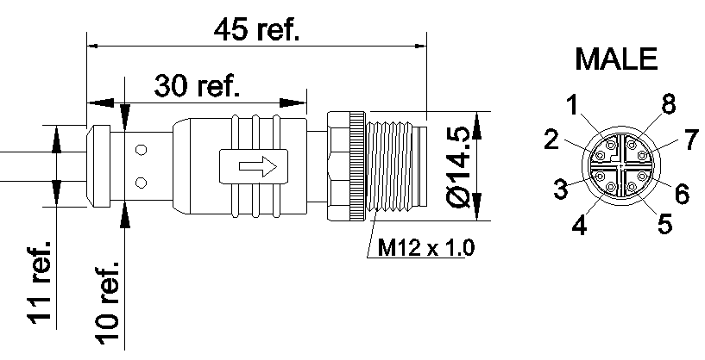

- General Information of Cable Assembly
Rated Current | 0.5A Max.
Rated Voltage | 48V DC
Insulation Resistance | ≥100MΩ
Contact Resistance | ≤5Ω
Operation Temperature | -25℃ ~+85℃
Poles | 8 Poles straight are available, right angle can be customized (refer to SKU Table)
Water Resistance Level | IP67 in locked condition, IP68 Can be customized
Cable | PUR/PVC cable (24, 26AWG) options

- SKU Table
SKU No. | Poles | Conn. Type | Overmoding Type | Remark
T-M12XSTM-08-001 | 8 | Male | Straight | With Metal Nut/Screw thread
T-M12XRAM-08-001 | 8 | Male | Right angle | With Metal Nut/Screw thread

- Dimensions of Related Components (Unit is mm)

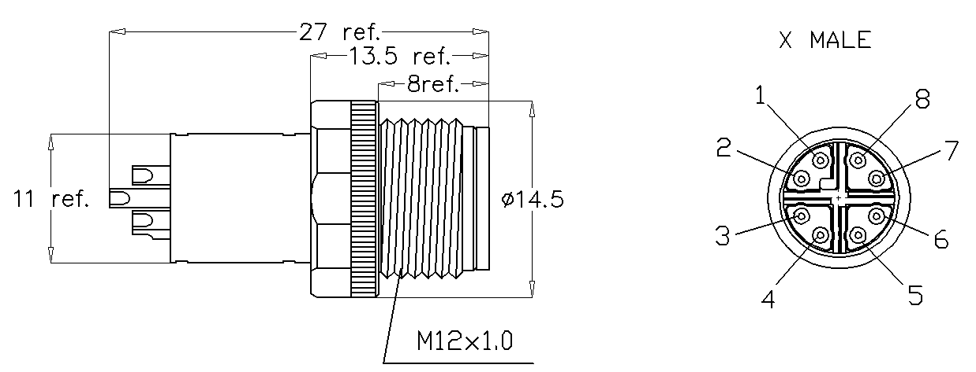

- General Information of Connector
Ambient Temperature: -25℃ ~ +85℃ Insulation Resistance: ≥100MΩ
Connector Body: PA66 Contact Resistance: ≤5mΩ
Connector Contacts: Brass with gold plated Shield: Available
Coupling Nut/Screw: Zinc alloy with nickel plated IP Rating: IP67 in locked condition
Mating Endurance: >500 Cycles

M8 Female (A Coding) Molded Cable, Straight, With Metal Nut (Screw Thread)
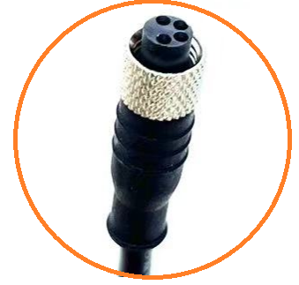

- Dimensions of Cable Assembly (Unit is mm)
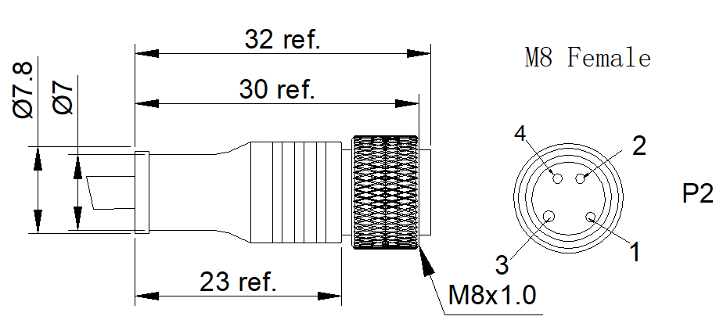

- General Information of Cable Assembly
Rated Current | 1.5A Max (6-8Pins), 3A Max (3-5Pins)
Rated Voltage | 30/60V DC
Insulation Resistance | ≥100MΩ
Contact Resistance | ≤5Ω
Operation Temperature | -20℃ ~+80℃
Poles | 3,4,6 Poles straight are available,  5,8 straight can be customized （Refer to below SKU table）  3,4,5,6,8 right angle can be customized too （Refer to below SKU table）
Water Resistance Level | IP67, IP68 in locked condition
Cable | PUR/PVC cable (24-26AWG) options

- Pins Layout
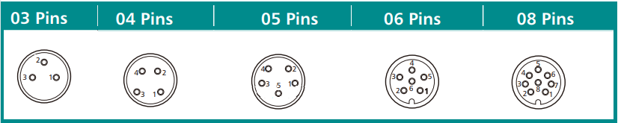

- SKU Table
SKU No. | Poles | Conn. Type | Overmoding Type | Remark
T-M8ASTF-03-001 | 3 | Female | Straight | With Metal Nut/Screw thread
T-M8ASTF-04-001 | 4 | Female | Straight | With Metal Nut/Screw thread
T-M8ASTF-05-001 | 5 | Female | Straight | With Metal Nut/Screw thread
T-M8ASTF-06-001 | 6 | Female | Straight | With Metal Nut/Screw thread
T-M8ASTF-08-001 | 8 | Female | Straight | With Metal Nut/Screw thread
T-M8ARAF-03-001 | 3 | Female | Right Angle | With Metal Nut/Screw thread
T-M8ARAF-04-001 | 4 | Female | Right Angle | With Metal Nut/Screw thread
T-M8ARAF-05-001 | 5 | Female | Right Angle | With Metal Nut/Screw thread
T-M8ARAF-06-001 | 6 | Female | Right Angle | With Metal Nut/Screw thread
T-M8ARAF-08-001 | 8 | Female | Right Angle | With Metal Nut/Screw thread

- Dimensions of Related Components (Unit is mm)
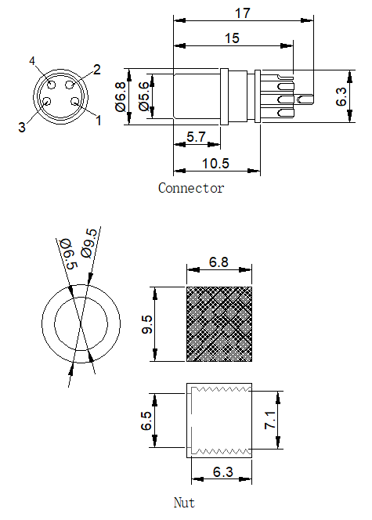

- General Information of Connector

Ambient Temperature: -25℃ ~ +85℃ Insulation Resistance: ≥100MΩ
Connector Body: PA66 Contact Resistance: ≤5mΩ
Connector Contacts: Brass with gold plated Shield: Available
Coupling Nut/Screw: Zinc alloy with nickel plated IP Rating: IP67 in locked condition
Mating Endurance: >500 Cycles
M8 Male (A Coding) Molded Cable, Straight, With Metal Nut (Screw Thread)
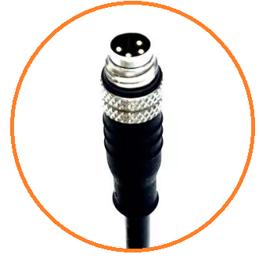

- General Information of Cable Assembly
Rated Current | 1.5A Max (6-8Pins), 3A Max (3-5Pins)
Rated Voltage | 30/60V DC
Insulation Resistance | ≥100MΩ
Contact Resistance | ≤5Ω
Operation Temperature | -20℃ ~+80℃
Poles | 3,4,6 Poles straight are available,  5,8 straight can be customized （Refer to below SKU table）  3,4,5,6,8 right angle can be customized too （Refer to below SKU table）
Water Resistance Level | IP67 in locked condition
Cable | PUR/PVC cable (24-26AWG) options

- SKU Table
SKU No. | Poles | Conn. Type | Overmoding Type | Remark
T-M8ASTM-03-001 | 3 | Male | Straight | With Metal Nut/Screw thread
T-M8ASTM-04-001 | 4 | Male | Straight | With Metal Nut/Screw thread
T-M8ASTM-05-001 | 5 | Male | Straight | With Metal Nut/Screw thread
T-M8ASTM-06-001 | 6 | Male | Straight | With Metal Nut/Screw thread
T-M8ASTM-08-001 | 8 | Male | Straight | With Metal Nut/Screw thread
T-M8ARAM-03-001 | 3 | Male | Right Angle | With Metal Nut/Screw thread
T-M8ARAM-04-001 | 4 | Male | Right Angle | With Metal Nut/Screw thread
T-M8ARAM-05-001 | 5 | Male | Right Angle | With Metal Nut/Screw thread
T-M8ARAM-06-001 | 6 | Male | Right Angle | With Metal Nut/Screw thread
T-M8ARAM-08-001 | 8 | Male | Right Angle | With Metal Nut/Screw thread

- Pins Layout
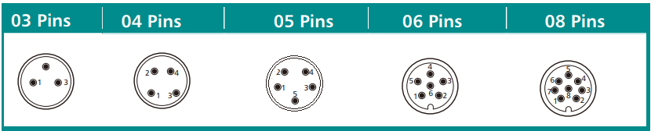

- Dimensions of Cable Assembly (Unit is mm)
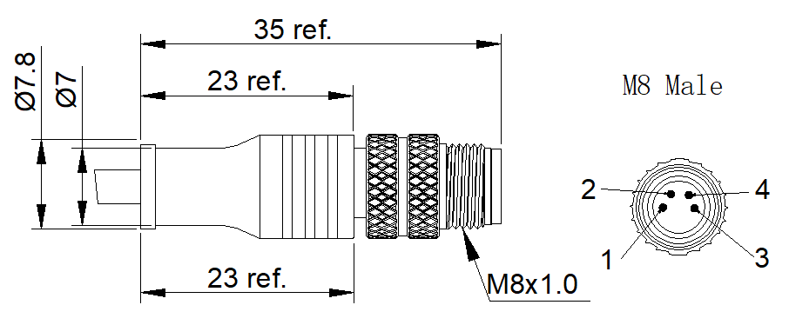

- Dimensions of Components
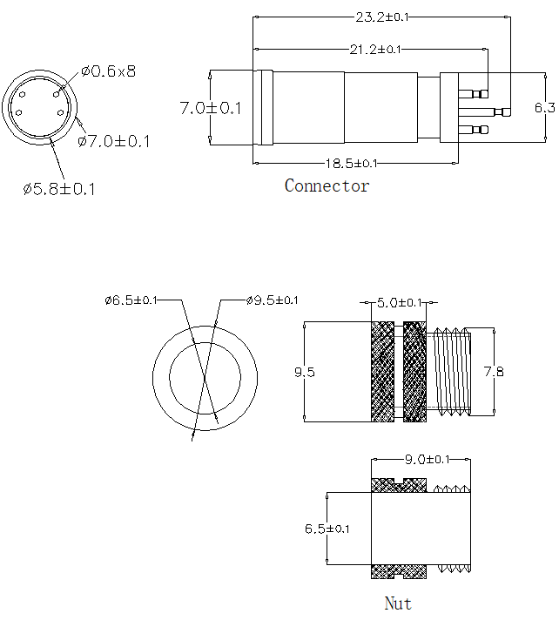

- General Information of Connector

Ambient Temperature: -25℃ ~ +85℃ Insulation Resistance: ≥100MΩ
Connector Body: PA66 Contact Resistance: ≤5mΩ
Connector Contacts: Brass with gold plated Shield: Available
Coupling Nut/Screw: Zinc alloy with nickel plated IP Rating: IP67 in locked condition
Mating Endurance: >500 Cycles

DIN Circle Female Molded Cable, Straight, With Shell
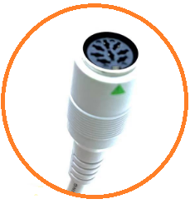

- Dimensions of Cable Assembly (Unit is mm)
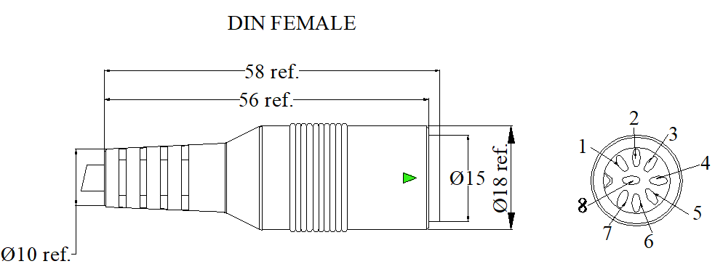

- General Information of Cable Assembly
Rated Current | 2A Max.
Rated Voltage | 12V DC
Insulation Resistance | ≥100MΩ
Contact Resistance | ≤5Ω
Operation Temperature | -20℃ ~+80℃
Poles | 8 Poles straight are available,  3-8 Poles straight can be customized （Refer to below SKU table）
Design Standard | Per VDE DIN standard
Cable | PUR/PVC cable (22-28AWG) options

- Pins Layout
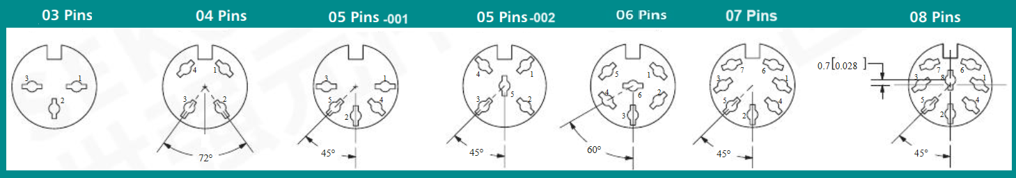

- SKU Table
SKU No. | Poles | Conn. Type | Overmoding Type | Remark
T-DINSTF-03-001 | 3 | Female | Straight | With shell
T- DINSTF-04-001 | 4 | Female | Straight | With shell
T- DINSTF-05-001 | 5 | Female | Straight | With shell, Pins 180 degree
T- DINSTF-05-002 | 5 | Female | Straight | With shell, one pin in the middle
T- DINSTF-06-001 | 6 | Female | Straight | With shell
T- DINSTF-07-001 | 7 | Female | Straight | With shell
T- DINSTF-08-001 | 8 | Female | Straight | With shell

- Dimensions of Related Components (Unit is mm)
Connector
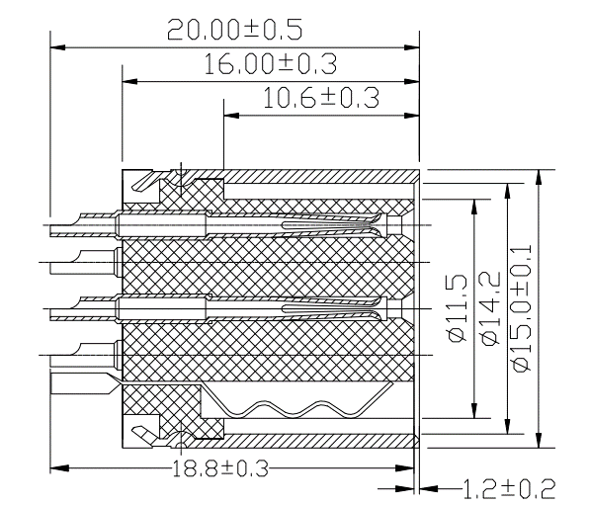

- General Information of Connector

Ambient Temperature: -20℃ ~ +80℃ Insulation Resistance: ≥100MΩ
Connector Body: PBT+GF/ABS Contact Resistance: ≤10mΩ
Connector Contacts: Brass with silver/tin Shell: Steel with nickel Mating Endurance: 5000 Cycles Pull Force: 3.5+/1 kg
DIN Circle Male Molded Cable, Straight, With Shell
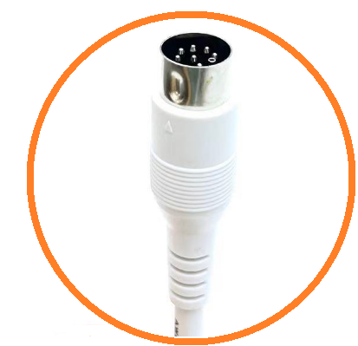

- Dimensions of Cable Assembly (Unit is mm)
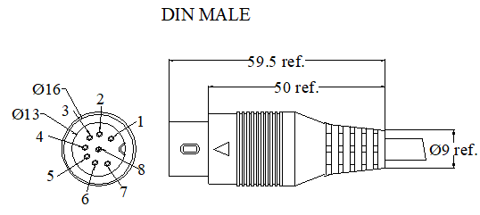

- General Information of Cable Assembly
Rated Current | 2A Max.
Rated Voltage | 12V DC
Insulation Resistance | ≥100MΩ
Contact Resistance | ≤5Ω
Operation Temperature | -20℃ ~+80℃
Poles | 8 Poles straight are available,  3-8 Poles straight can be customized （Refer to below SKU table）
Design Standard | Per VDE DIN standard
Cable | PUR/PVC cable (22-28AWG) options

- Pins Layout
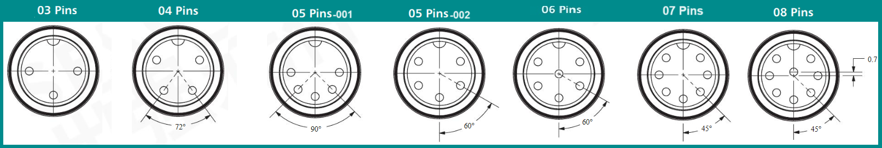
- SKU Table
SKU No. | Poles | Conn. Type | Overmoding Type | Remark
T-DINSTM-03-001 | 3 | Male | Straight | With shell
T- DINSTM-04-001 | 4 | Male | Straight | With shell
T- DINSTM-05-001 | 5 | Male | Straight | With shell, Pins with 180 degree
T- DINSTM-05-002 | 5 | Male | Straight | With shell, Pins within 240 degree
T- DINSTM-06-001 | 6 | Male | Straight | With shell
T- DINSTM-07-001 | 7 | Male | Straight | With shell
T- DINSTM-08-001 | 8 | Male | Straight | With shell

- Dimensions of Related Components (Unit is mm)

Connector
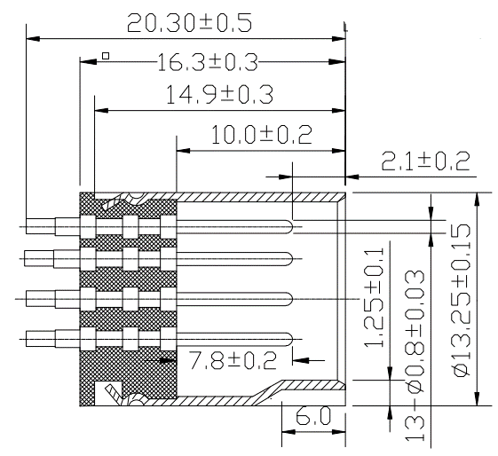

- General Information of Connector

Ambient Temperature: -20℃ ~ +80℃ Insulation Resistance: ≥100MΩ
Connector Body: PBT+GF/ABS Contact Resistance: ≤10mΩ
Connector Contacts: Brass with silver/tin Shell: Steel with nickel Mating Endurance: 5000 Cycles Pull Force: 3.5+/1 kg

DIN Male Molded Cable, Right Angle, With Shell
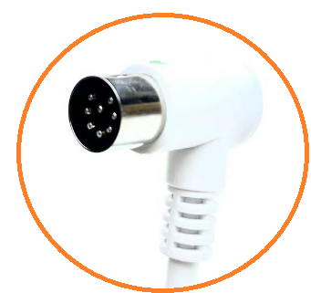

- Dimensions of Cable Assembly (Unit is mm)
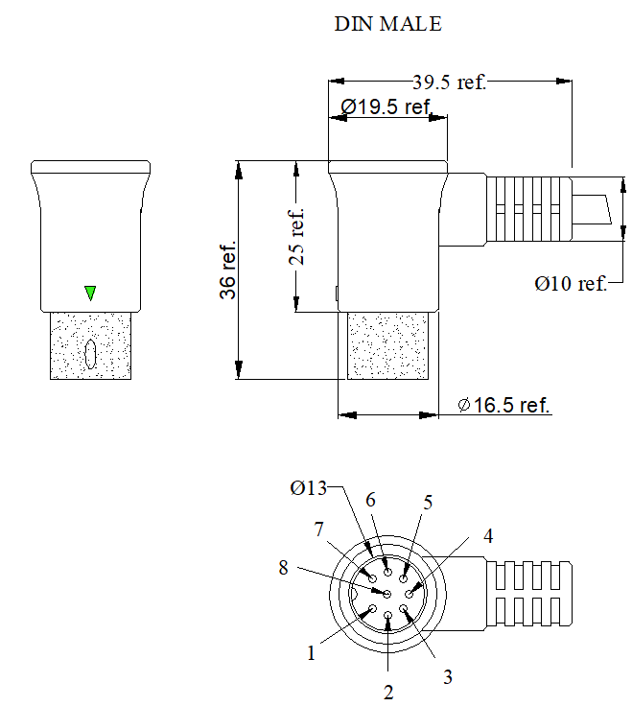

- General Information of Cable Assembly
Rated Current | 2A Max.
Rated Voltage | 12V DC
Insulation Resistance | ≥100MΩ
Contact Resistance | ≤5Ω
Operation Temperature | -20℃ ~+80℃
Poles | 8 Poles straight are available,  3-8 Poles straight can be customized （Refer to below SKU table）
Design Standard | Per VDE DIN standard
Cable | PUR/PVC cable (22-28AWG) options

- Pins Layout
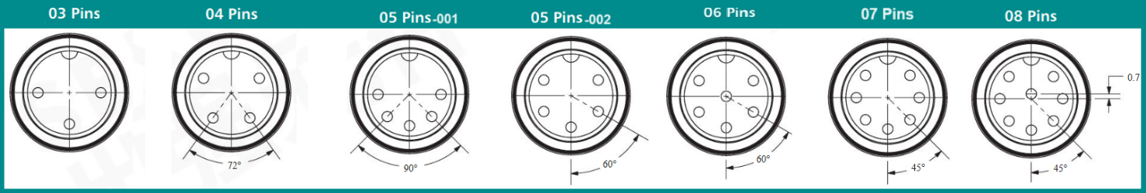
- SKU Table
SKU No. | Poles | Conn. Type | Overmoding Type | Remark
T-DINRAM-03-001 | 3 | Male | Right Angle | With shell
T- DINRAM-04-001 | 4 | Male | Right Angle | With shell
T- DINRAM-05-001 | 5 | Male | Right Angle | With shell, Pins with 180 degree
T- DINRAM-05-002 | 5 | Male | Right Angle | With shell, Pins within 240 degree
T- DINRAM-06-001 | 6 | Male | Right Angle | With shell
T- DINRAM-07-001 | 7 | Male | Right Angle | With shell
T- DINRAM-08-001 | 8 | Male | Right Angle | With shell

- Dimensions of Related Components (Unit is mm)
Connector

- General Information of Connector
Ambient Temperature: -20℃ ~ +85℃ Insulation Resistance: ≥100MΩ
Connector Body: PBT+GF/ABS Contact Resistance: ≤10mΩ
Connector Contacts: Brass with silver/tin Shell: Steel with nickel Mating Endurance: 5000 Cycles Pull Force: 3.5+/1 kg

9Pin MINI DIN Female Molded Cable, Straight, With Shell
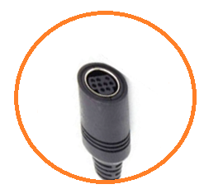

- Dimensions of Cable Assembly (Unit is mm)
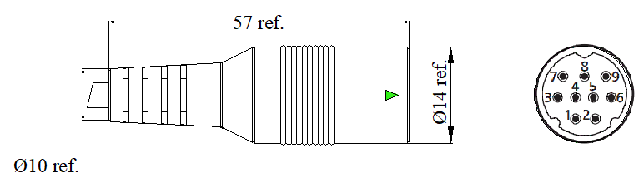

- General Information of Cable Assembly
Rated Current | 1.5A Max.
Rated Voltage | 12V
Insulation Resistance | ≥100MΩ
Contact Resistance | ≤5Ω
Operation Temperature | -20℃ ~+80℃
Poles | 3-9 Poles straight can be customized（Refer to below SKU table）
Design Standard | Per VDE DIN standard
Cable | PUR/PVC cable (22-28AWG) options

- Pins Layout
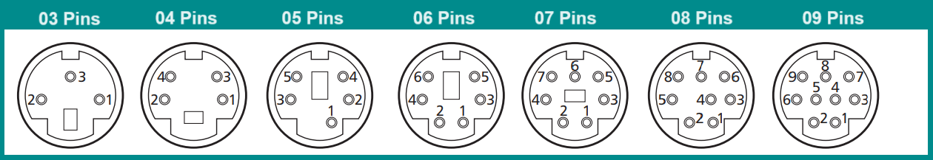

- SKU Table
SKU No. | Poles | Conn. Type | Overmoding Type | Remark
T-MDINSTF-03-001 | 3 | Female | Straight | With shell
T- MDINSTF-04-001 | 4 | Female | Straight | With shell
T- MDINSTF-05-001 | 5 | Female | Straight | With shell
T- MDINSTF-06-001 | 6 | Female | Straight | With shell
T- MDINSTF-07-001 | 7 | Female | Straight | With shell
T- MDINSTF-08-001 | 8 | Female | Straight | With shell
T- MDINSTF-09-001 | 9 | Female | Straight | With shell

- Dimensions of Related Components (Unit is mm)
Connector
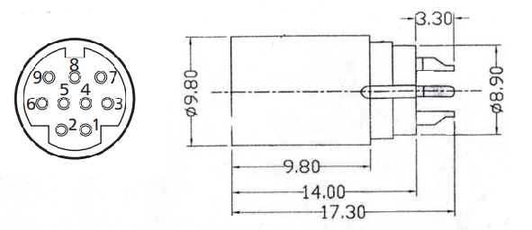

- General Information of Connector

Ambient Temperature: -20℃ ~ +80℃ Insulation Resistance: ≥100MΩ
Connector Body: PBT+GF/ABS Contact Resistance: ≤10mΩ
Connector Contacts: Brass with silver/tin Shell: Steel with nickel
MINI DIN Male Molded Cable, Straight, With Shell
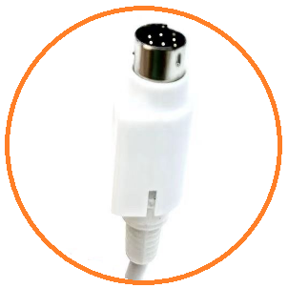

- Dimensions of Cable Assembly (Unit is mm)
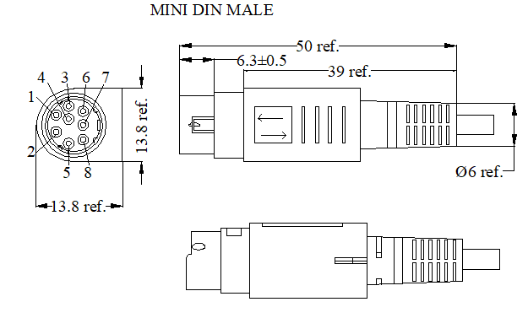

- General Information of Cable Assembly
Rated Current | 1.5A Max.
Rated Voltage | 12V
Insulation Resistance | ≥100MΩ
Contact Resistance | ≤5Ω
Operation Temperature | -20℃ ~+80℃
Poles | 6, 8 Poles are available, 3-9 Poles straight can be customized（Refer to SKU table）
Design Standard | Per VDE DIN standard
Cable | PUR/PVC cable (22-28AWG) options

- Pins Layout
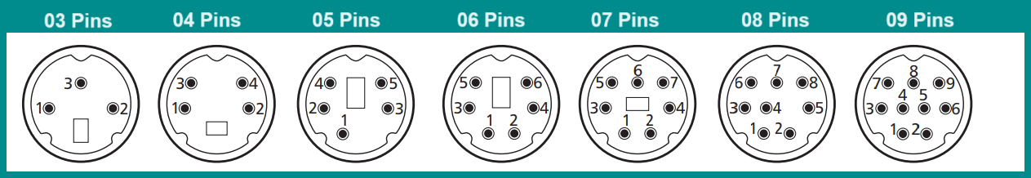

- SKU Table
SKU No. | Poles | Conn. Type | Overmoding Type | Remark
T-MDINSTM-03-001 | 3 | Male | Straight | With shell
T- MDINSTM-04-001 | 4 | Male | Straight | With shell
T- MDINSTM-05-001 | 5 | Male | Straight | With shell
T- MDINSTM-06-001 | 6 | Male | Straight | With shell
T- MDINSTM-07-001 | 7 | Male | Straight | With shell
T- MDINSTM-08-001 | 8 | Male | Straight | With shell
T- MDINSTM-09-001 | 9 | Male | Straight | With shell

- Dimensions of Related Components (Unit is mm)
Connector
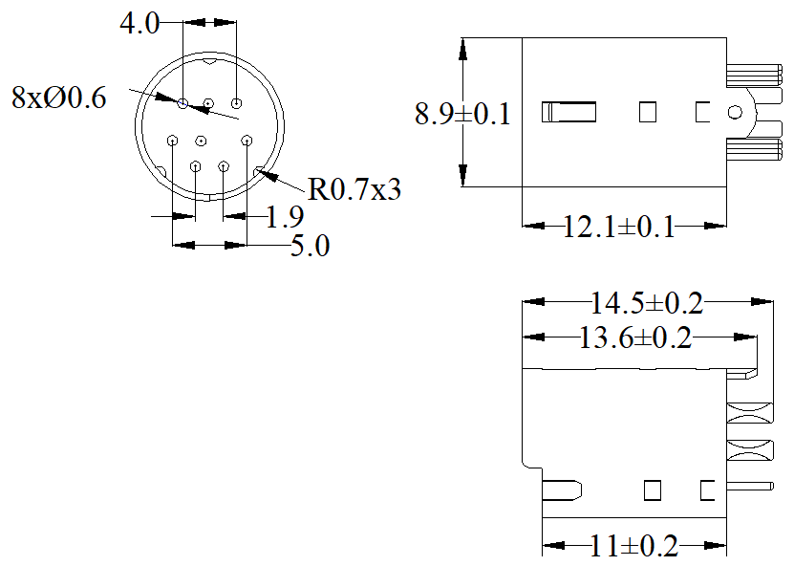

- General Information of Connector

Ambient Temperature: -20℃ ~ +80℃ Insulation Resistance: ≥100MΩ
Connector Body: PBT+GF/ABS Contact Resistance: ≤10mΩ
Connector Contacts: Brass with silver/tin Shell: Steel with nickel

9Pin D-SUB Female Molded Cable Assembly, Straight
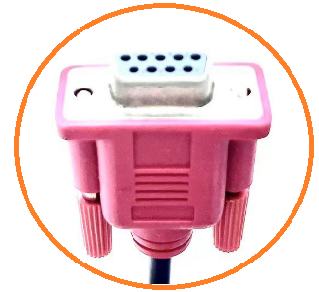

- Dimensions of Cable Assembly (Unit is mm)
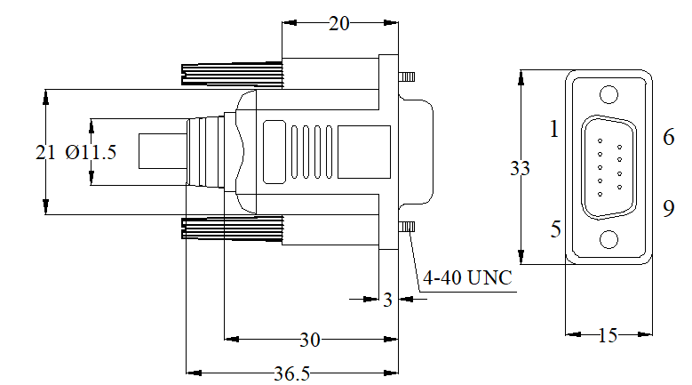

- General Information of Cable Assembly
Rated Current | 4A Max.
Rated Voltage | 30V
Insulation Resistance | ≥100MΩ
Contact Resistance | ≤5Ω
Operation Temperature | -20℃ ~+70℃
Poles | 9 Poles straight are available,  9 Poles right angle can be customized （Refer to below SKU table）
Cable | PUR/PVC cable (18-28AWG) options
Water Resistance | IP67 in lock condition can be customized if need

- SKU Table
SKU No. | Poles | Conn. Type | Overmoding Type | Remark
T-DSUBSTF-09-001 | 9 | Female | Straight | Locking type: Fix screw
T- DSUBRAF-09-001 | 9 | Female | Right Angle | Locking type: Fix screw

- Dimensions of Related Components (Unit is mm)
Connector
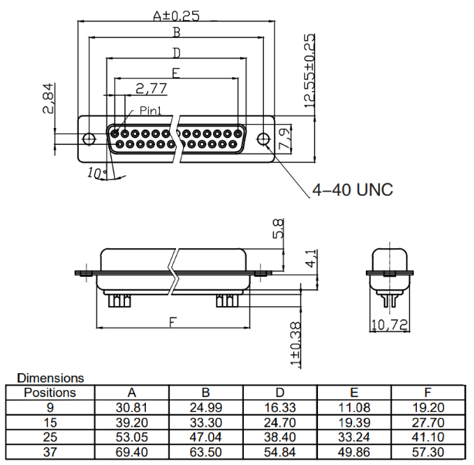

- General Information of Connector

Ambient Temperature: -25℃ ~ +70℃ Insulation Resistance: ≥100MΩ
Connector Body: PBT Contact Resistance: ≤10mΩ
Connector Contacts: Brass with nickel/gold plated Shell: Unavailable
Pitch： 2.84mm Mating Endurance: 500 Cycles

9 Pin D-SUB Male Molded Cable Assembly, Straight
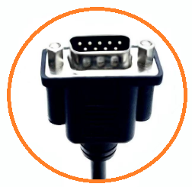

- Dimensions of Cable Assembly (Unit is mm)
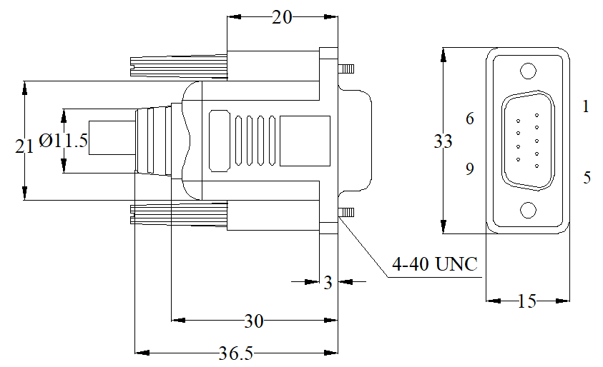

- SKU Table
SKU No. | Poles | Conn. Type | Overmoding Type | Remark
T-DSUBSTM-09-001 | 9 | Male | Straight | Locking type: Fix screw
T- DSUBRAM-09-001 | 9 | Male | Right Angle | Locking type: Fix screw

- General Information of Cable Assembly
Rated Current | 4A Max.
Rated Voltage | 30V
Insulation Resistance | ≥100MΩ
Contact Resistance | ≤5Ω
Operation Temperature | -20℃ ~+70℃
Poles | 9 Poles straight are available,  9 Poles right angle can be customized （Refer to below SKU table）
Cable | PUR/PVC cable (18-28AWG) options
Water Resistance | IP67 in lock condition can be customized if need

- Dimensions of Connector (Unit is mm)
Connector
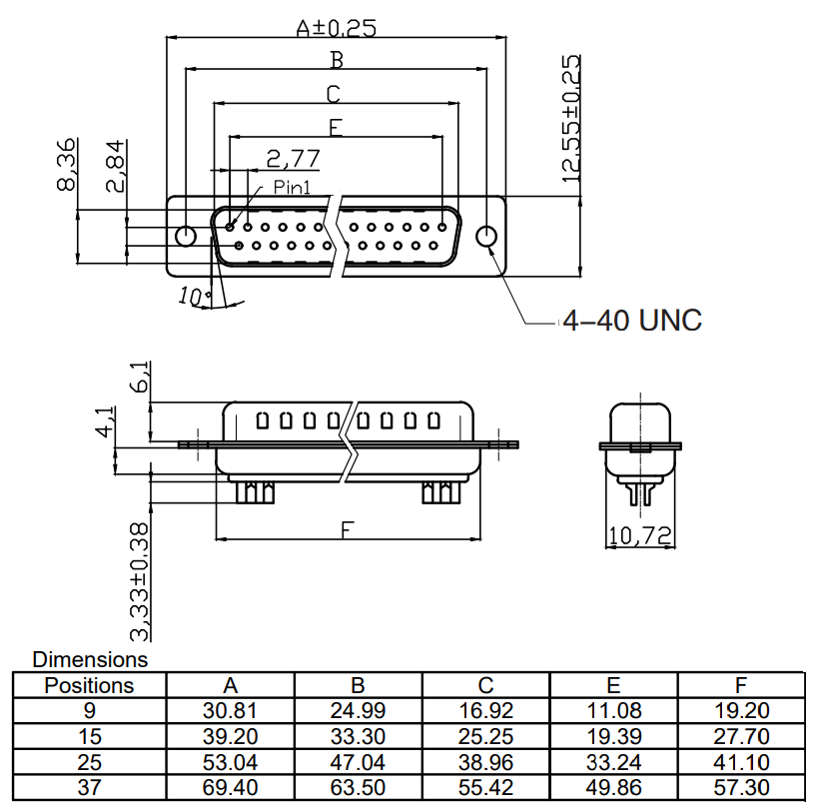

- General Information of Connector

Ambient Temperature: -25℃ ~ +70℃ Insulation Resistance: ≥100MΩ
Connector Body: PBT Contact Resistance: ≤10mΩ
Connector Contacts: Brass with nickel/gold plated Shell: Unavailable
Pitch： 2.84mm Mating Endurance: 500 Cycles

15 Pin D-SUB Female Molded Cable Assembly, Straight
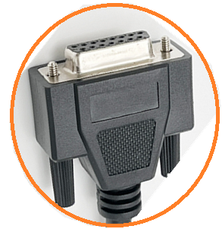

- Dimensions of Cable Assembly (Unit is mm)
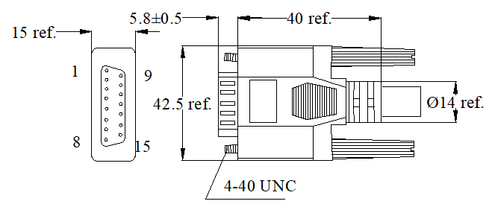

- SKU Table
SKU No. | Poles | Conn. Type | Overmoding Type | Remark
T-DSUBSTF-15-001 | 15 | Female | Straight | Locking type: Fix screw
T- DSUBRAF-15-001 | 15 | Female | Right Angle | Locking type: Fix screw

- General Information of Cable Assembly (Unit is mm)
Rated Current | 4A Max.
Rated Voltage | 30V
Insulation Resistance | ≥100MΩ
Contact Resistance | ≤5Ω
Operation Temperature | -20℃ ~+70℃
Poles | 15 Poles straight are available,  15 Poles right angle can be customized （Refer to below SKU table）
Cable | PUR/PVC cable (18-28AWG) options
Water Resistance | IP67 in lock condition can be customized if need

- Dimensions of Connector (Unit is mm)
Connector

- General Information of Connector

Ambient Temperature: -25℃ ~ +70℃ Insulation Resistance: ≥100MΩ
Connector Body: PBT Contact Resistance: ≤10mΩ
Connector Contacts: Brass with nickel/gold plated Shell: Unavailable
Pitch： 2.84mm Mating Endurance: 500 Cycles

15 Pin D-SUB Male Molded Cable Assembly, Straight
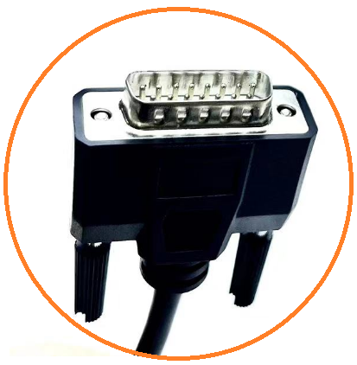

- Dimensions of Cable Assembly (Unit is mm)
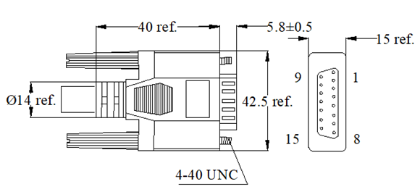

- General Information of Cable Assembly
Rated Current | 4A Max.
Rated Voltage | 30V
Insulation Resistance | ≥100MΩ
Contact Resistance | ≤5Ω
Operation Temperature | -20℃ ~+70℃
Poles | 15 Poles straight are available,  15 Poles right angle can be customized （Refer to below SKU table）
Cable | PUR/PVC cable (18-28AWG) options
Water Resistance | IP67 in lock condition can be customized if need

- SKU Table
SKU No. | Poles | Conn. Type | Overmoding Type | Remark
T-DSUBSTM-15-001 | 15 | Male | Straight | Locking type: Fix screw
T- DSUBRAM-15-001 | 15 | Male | Right Angle | Locking type: Fix screw

- Dimensions of Connector (Unit is mm)
Connector

- General Information of Connector

Ambient Temperature: -25℃ ~ +70℃ Insulation Resistance: ≥100MΩ
Connector Body: PBT Contact Resistance: ≤10mΩ
Connector Contacts: Brass with nickel/gold plated Shell: Unavailable
Pitch： 2.84mm Mating Endurance: 500 Cycles

25 Pin D-SUB Female Molded Cable Assembly, Straight
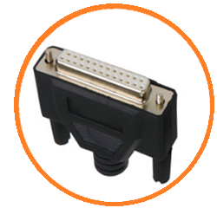

- Dimensions of Cable Assembly (Unit is mm)
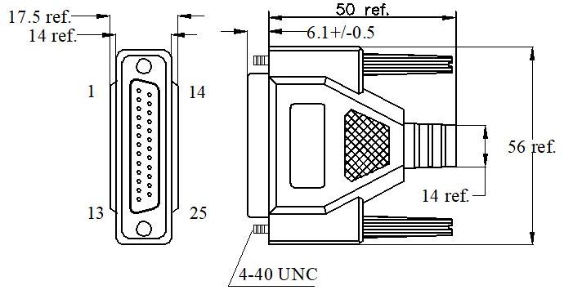

- SKU Table
SKU No. | Poles | Conn. Type | Overmoding Type | Remark
T-DSUBSTF-25-001 | 25 | Female | Straight | Locking type: Fix screw
T- DSUBRAF-25-001 | 25 | Female | Right Angle | Locking type: Fix screw

- General Information of Cable Assembly
Rated Current | 4A Max.
Rated Voltage | 30V
Insulation Resistance | ≥100MΩ
Contact Resistance | ≤5Ω
Operation Temperature | -20℃ ~+70℃
Poles | 25 Poles straight are available,  25 Poles right angle can be customized （Refer to below SKU table）
Cable | PUR/PVC cable (18-28AWG) options
Water Resistance | IP67 in lock condition can be customized if need

- Dimensions of Connector (Unit is mm)
Connector

- General Information of Connector
Ambient Temperature: -25℃ ~ +70℃ Insulation Resistance: ≥100MΩ
Connector Body: PBT Contact Resistance: ≤10mΩ
Connector Contacts: Brass with nickel/gold plated Shell: Unavailable
Pitch： 2.84mm Mating Endurance: 500 Cycles
25 Pin D-SUB Male Molded Cable Assembly, Straight
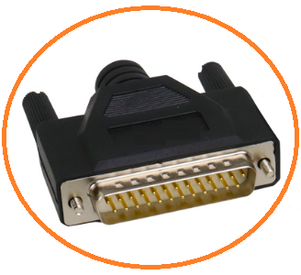

- Dimensions of Cable Assembly (Unit is mm)
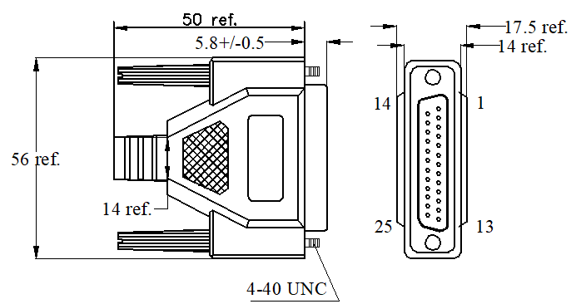

- General Information of Cable Assembly
Rated Current | 4A Max.
Rated Voltage | 30V
Insulation Resistance | ≥100MΩ
Contact Resistance | ≤5Ω
Operation Temperature | -20℃ ~+70℃
Poles | 25 Poles straight are available,  25 Poles right angle can be customized （Refer to below SKU table）
Cable | PUR/PVC cable (18-28AWG) options
Water Resistance | IP67 in lock condition can be customized if need

- SKU Table
SKU No. | Poles | Conn. Type | Overmoding Type | Remark
T-DSUBSTM-25-001 | 25 | Male | Straight | Locking type: Fix screw
T- DSUBRAM-25-001 | 25 | Male | Right Angle | Locking type: Fix screw

- Dimensions of Connector (Unit is mm)
Connector

- General Information of Connector
Ambient Temperature: -25℃ ~ +70℃ Insulation Resistance: ≥100MΩ
Connector Body: PBT Contact Resistance: ≤10mΩ
Connector Contacts: Brass with nickel/gold plated Shell: Unavailable
Pitch： 2.84mm Mating Endurance: 500 Cycles

37Pin D-SUB Female Molded Cable Assembly, Straight
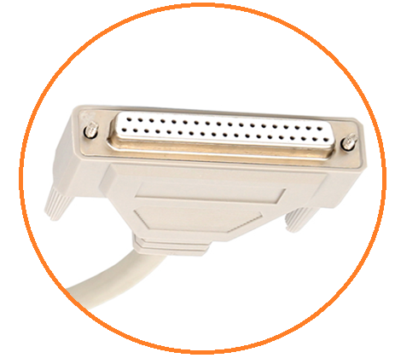

- Dimensions of Cable Assembly (Unit is mm)
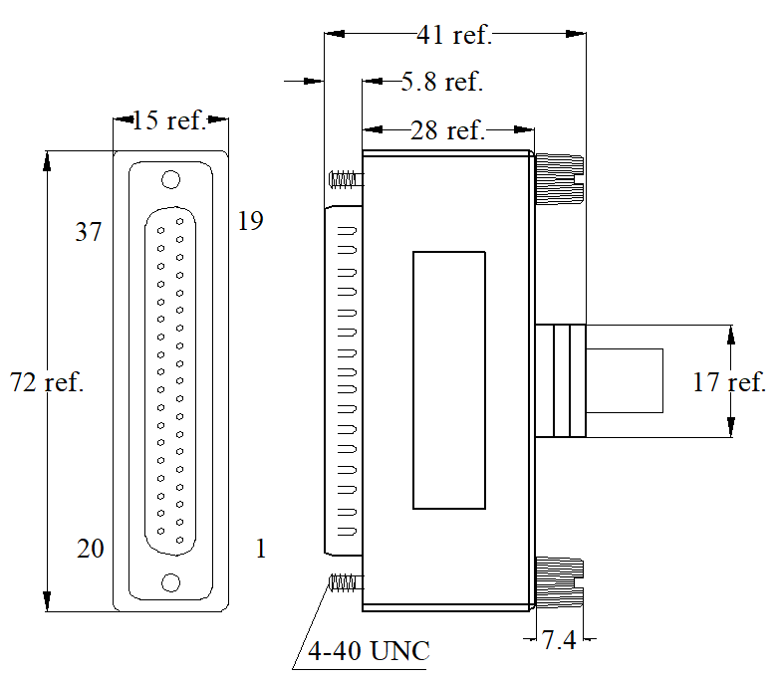

- General Information of Cable Assembly
Rated Current | 4A Max.
Rated Voltage | 30V
Insulation Resistance | ≥100MΩ
Contact Resistance | ≤5Ω
Operation Temperature | -20℃ ~+70℃
Poles | 37 Poles straight and right angle can be customized (Refer to below SKU table)
Cable | PUR/PVC cable (18-28AWG) options
Water Resistance | IP67 in lock condition can be customized if need

- SKU Table
SKU No. | Poles | Conn. Type | Overmoding Type | Remark
T-DSUBSTF-37-001 | 37 | Female | Straight | Locking type: Fix screw
T- DSUBRAF-37-001 | 37 | Female | Right Angle | Locking type: Fix screw

- Dimensions of Connector (Unit is mm)
Connector

- General Information of Connector
Ambient Temperature: -25℃ ~ +70℃ Insulation Resistance: ≥100MΩ
Connector Body: PBT Contact Resistance: ≤10mΩ
Connector Contacts: Brass with nickel/gold plated Shell: Unavailable
Pitch： 2.84mm Mating Endurance: 500 Cycles

37 Pin D-SUB Male Molded Cable Assembly, Straight
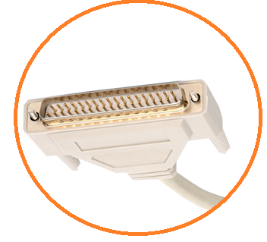

- Dimensions of Cable Assembly (Unit is mm)
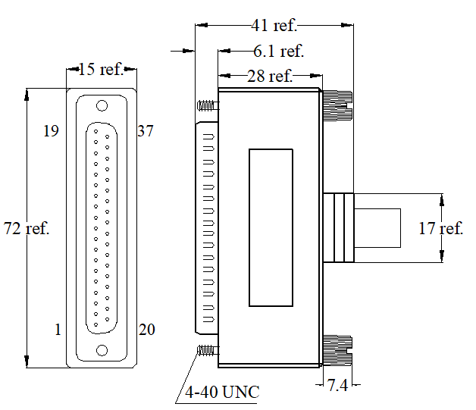

- SKU Table
SKU No. | Poles | Conn. Type | Overmoding Type | Remark
T-DSUBSTM-37-001 | 37 | Male | Straight | Locking type: Fix screw
T- DSUBRAM-37-001 | 37 | Male | Right Angle | Locking type: Fix screw

- General Information of Cable Assembly
Rated Current | 4A Max.
Rated Voltage | 30V
Insulation Resistance | ≥100MΩ
Contact Resistance | ≤5Ω
Operation Temperature | -20℃ ~+70℃
Poles | 37 Poles straight are available,  37 Poles right angle can be customized （Refer to below SKU table）
Cable | PUR/PVC cable (18-28AWG) options
Water Resistance | IP67 in lock condition can be customized if need

- Dimensions of Connector (Unit is mm)
Connector

- General Information of Connector

Ambient Temperature: -25℃ ~ +70℃ Insulation Resistance: ≥100MΩ
Connector Body: PBT Contact Resistance: ≤10mΩ
Connector Contacts: Brass with nickel/gold plated Shell: Unavailable
Pitch： 2.84mm Mating Endurance: 500 Cycles

15Pin High Density D-SUB Female Molded Cable Assembly, Straight
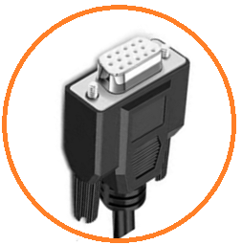

- Dimensions of Cable Assembly (Unit is mm)
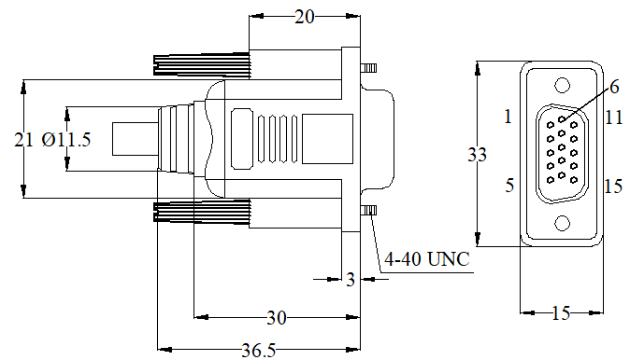

- SKU Table
SKU No. | Poles | Conn. Type | Overmoding Type | Remark
T-HDBSTF-15-001 | 15 | Female | Straight | Locking type: Fix screw
T-HDBSTF-26-001 | 26 | Female | Straight | Locking type: Fix screw
T-HDBSTF-44-001 | 44 | Female | Straight | Locking type: Fix screw
T-HDBSTF-62-001 | 62 | Female | Straight | Locking type: Fix screw
T-HDBSTF-78-001 | 78 | Female | Straight | Locking type: Fix screw
T-HDBRAF-15-001 | 15 | Female | Right Angle | Locking type: Fix screw
T-HDBRAF-26-001 | 26 | Female | Right Angle | Locking type: Fix screw
T-HDBRAF-44-001 | 44 | Female | Right Angle | Locking type: Fix screw
T-HDBRAF-62-001 | 62 | Female | Right Angle | Locking type: Fix screw
T-HDBRAF-78-001 | 78 | Female | Right Angle | Locking type: Fix screw

- General Information of Cable Assembly
Rated Current | 5A Max.
Rated Voltage | 30V
Insulation Resistance | ≥100MΩ
Contact Resistance | ≤5Ω
Operation Temperature | -20℃ ~+70℃
Poles | 15 Poles straight is available,  26, 44,62,78 Poles straight/right angle can be customized (Refer to SKU table)
Cable | PUR/PVC cable (18-28AWG) options
Water Resistance | IP67 in lock condition can be customized if need

- Dimensions of Connector (Unit is mm)
Connector
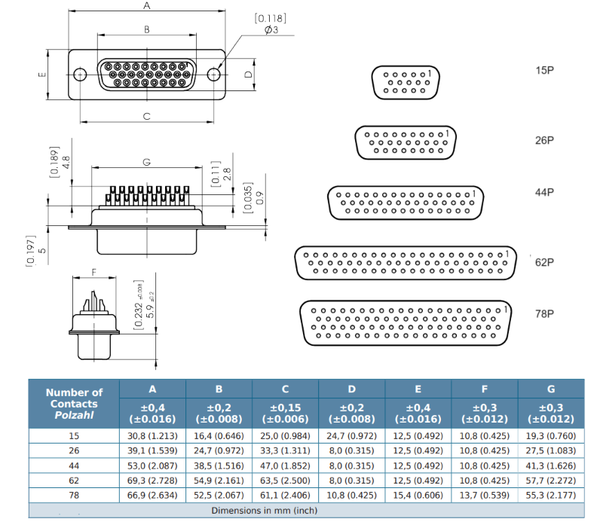

- General Information of Connector

Ambient Temperature: -25℃ ~ +70℃ Insulation Resistance: ≥100MΩ
Connector Body: PBT Contact Resistance: ≤15mΩ
Connector Contacts: Brass with nickel/gold plated Shell: Unavailable
Pitch： 1.98mm Mating Endurance: 500 Cycles

15Pin High Density D-SUB Male Molded Cable Assembly, Straight
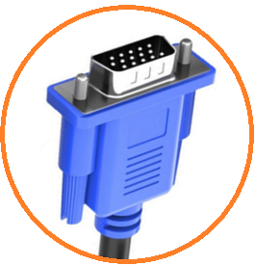

- Dimensions of Cable Assembly (Unit is mm)
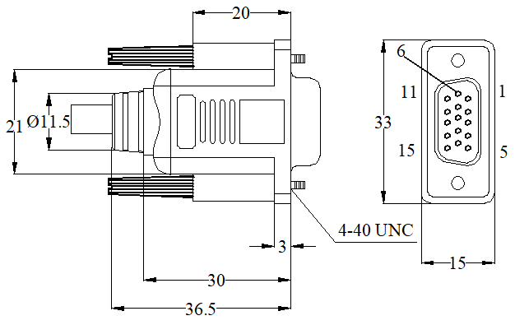

- SKU Table
SKU No. | Poles | Conn. Type | Overmoding Type | Remark
T-HDBSTM-15-001 | 15 | Male | Straight | Locking type: Fix screw
T-HDBSTM-26-001 | 26 | Male | Straight | Locking type: Fix screw
T-HDBSTM-44-001 | 44 | Male | Straight | Locking type: Fix screw
T-HDBSTM-62-001 | 62 | Male | Straight | Locking type: Fix screw
T-HDBSTM-78-001 | 78 | Male | Straight | Locking type: Fix screw
T- HDBRAM-15-001 | 15 | Male | Right Angle | Locking type: Fix screw
T- HDBRAM-26-001 | 26 | Male | Right Angle | Locking type: Fix screw
T- HDBRAM-44-001 | 44 | Male | Right Angle | Locking type: Fix screw
T- HDBRAM-62-001 | 62 | Male | Right Angle | Locking type: Fix screw
T- HDBRAM-78-001 | 78 | Male | Right Angle | Locking type: Fix screw

- General Information of Cable Assembly
Rated Current | 5A Max.
Rated Voltage | 30V
Insulation Resistance | ≥100MΩ
Contact Resistance | ≤5Ω
Operation Temperature | -20℃ ~+70℃
Poles | 15 Poles straight are available,  26, 44,62,78 Poles straight/right angle can be customized （Refer to SKU table）
Cable | PUR/PVC cable (18-28AWG) options
Water Resistance | IP67 in lock condition can be customized if need

- Dimensions of Connector (Unit is mm)
Connector
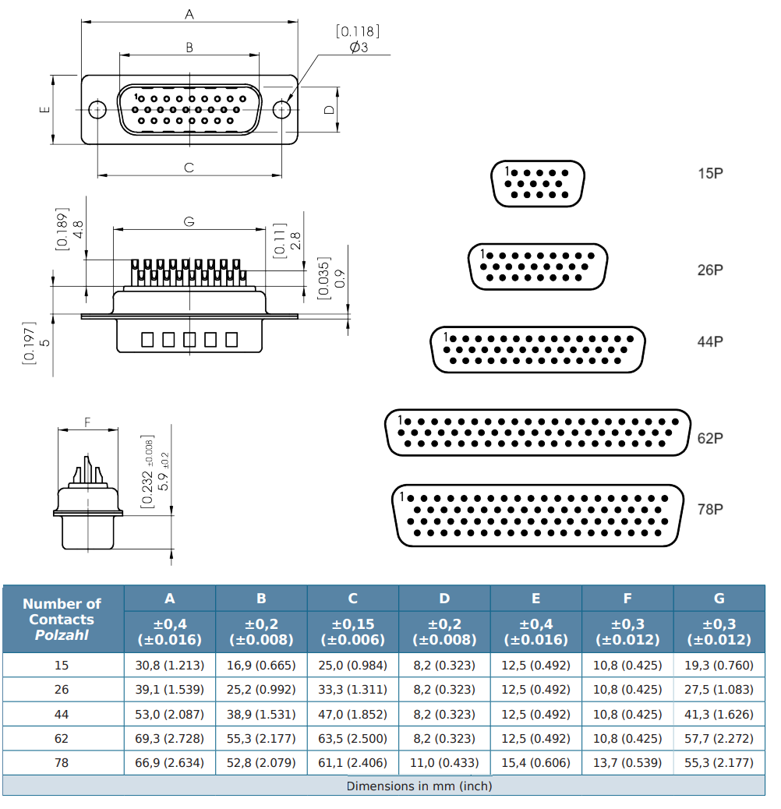

- General Information of Connector

Ambient Temperature: -25℃ ~ +70℃ Insulation Resistance: ≥100MΩ
Connector Body: PBT Contact Resistance: ≤15mΩ
Connector Contacts: Brass with nickel/gold plated Shell: Unavailable
Pitch： 1.98mm Mating Endurance: 500 Cycles

27W2 Hybrid D-SUB Female Molded Cable Assembly, Straight
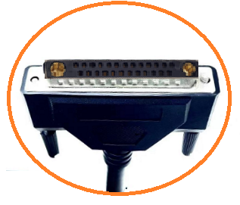

- Dimensions of Cable Assembly (Unit is mm)

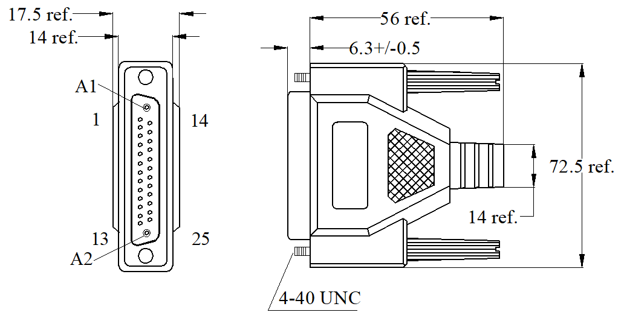

- General Information of Cable Assembly
Rated Current | 7.5A Max.
Rated Voltage | 30V
Insulation Resistance | ≥100MΩ
Contact Resistance | ≤5Ω
Operation Temperature | -20℃ ~+80℃
Poles | 5W5,7W2, 9W4, 11W1, 13W3, 27W2 Poles straight/right angle can be customized (Refer to SKU table)
Cable | PUR/PVC cable (16-20AWG) options
Water Resistance | IP67 in lock condition can be customized if need

- Dimensions of Connector (Unit is mm)
Connector
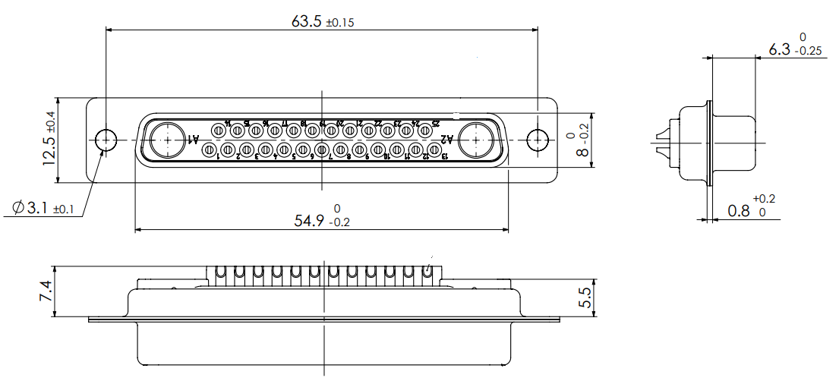

- General Information of Connector

Ambient Temperature: -25℃ ~ +70℃ Insulation Resistance: ≥100MΩ
Connector Body: PBT Contact Resistance: ≤15mΩ
Connector Contacts: Brass with nickel/gold plated Shell: Unavailable
Pitch： 2.84mm Mating Endurance: 500 Cycles.

27W2 Hybrid D-SUB Male Molded Cable Assembly, Straight

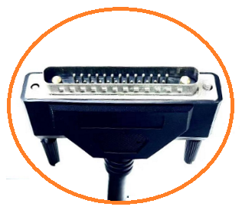

- Dimensions of Cable Assembly (Unit is mm)

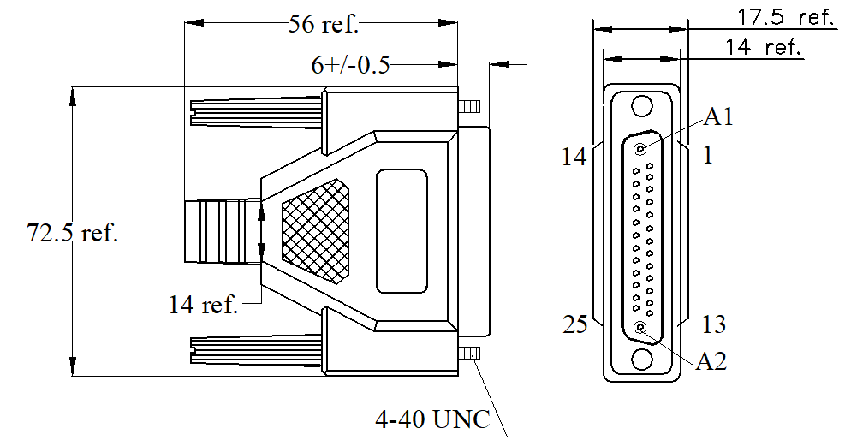

- General Information of Cable Assembly
Rated Current | 7.5A Max.
Rated Voltage | 30V
Insulation Resistance | ≥100MΩ
Contact Resistance | ≤5Ω
Operation Temperature | -20℃ ~+80℃
Poles | 27W2 Poles straight are available,  5W5,7W2, 9W4, 11W1, 13W3 Poles straight/right angle can be customized (Refer to SKU table)
Cable | PUR/PVC cable (16-20AWG) options
Water Resistance | IP67 in lock condition can be customized if need

- SKU Table
SKU No. | Poles | Conn. Type | Overmoding Type | Remark
T-HDSUBSTM-05-001 | 5+0 | Male | Straight | Locking type: Fix screw
T-HDSUBSTM-07-001 | 5+2 | Male | Straight | Locking type: Fix screw
T-HDSUBSTM-09-001 | 5+4 | Male | Straight | Locking type: Fix screw
T-HDSUBSTM-11-001 | 10+1 | Male | Straight | Locking type: Fix screw
T-HDSUBSTM-13-001 | 10+3 | Male | Straight | Locking type: Fix screw
T-HDSUBSTM-27-001 | 25+2 | Male | Straight | Locking type: Fix screw
T-HDSUBRAM-05-001 | 5+0 | Male | Right Angle | Locking type: Fix screw
T-HDSUBRAM-07-001 | 5+2 | Male | Right Angle | Locking type: Fix screw
T-HDSUBRAM-09-001 | 5+4 | Male | Right Angle | Locking type: Fix screw
T-HDSUBRAM-11-001 | 10+1 | Male | Right Angle | Locking type: Fix screw
T-HDSUBRAM-13-001 | 10+3 | Male | Right Angle | Locking type: Fix screw
T-HDSUBRAM-27-001 | 25+2 | Male | Right Angle | Locking type: Fix screw

- Dimensions of Connector (Unit is mm)
Connector
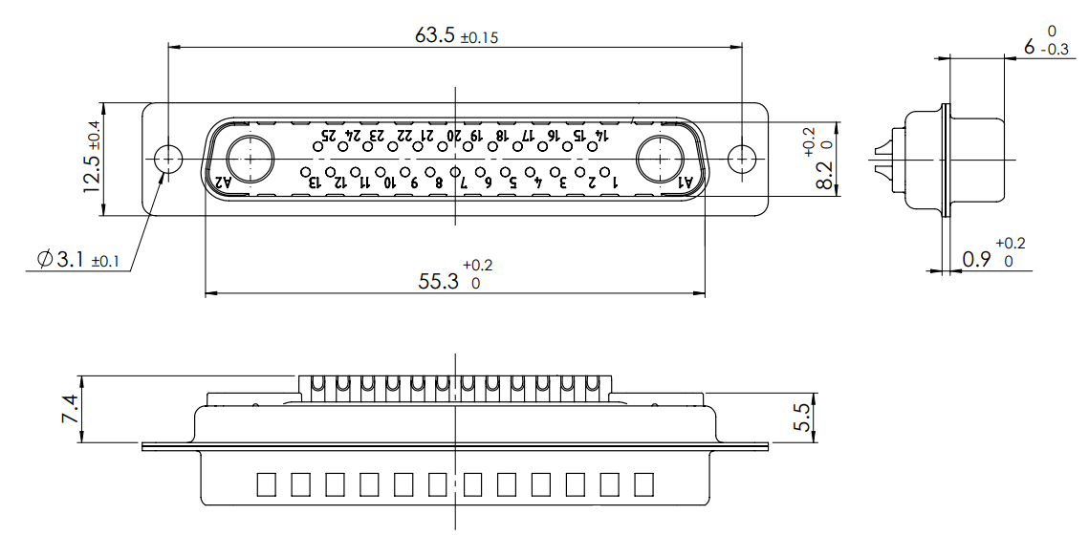

- General Information of Connector

Ambient Temperature: -35℃ ~ +85℃ Insulation Resistance: ≥100MΩ
Connector Body: PBT Contact Resistance: ≤15mΩ
Connector Contacts: Brass with nickel/gold plated Shell: Available
Pitch： 2.84mm Mating Endurance: 500 Cycles

9Pin Micro D-SUB Female Molded Cable Assembly, Straight
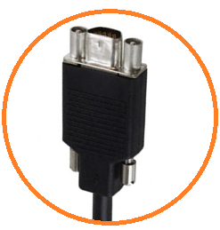

- Dimensions of Cable Assembly (Unit is mm)

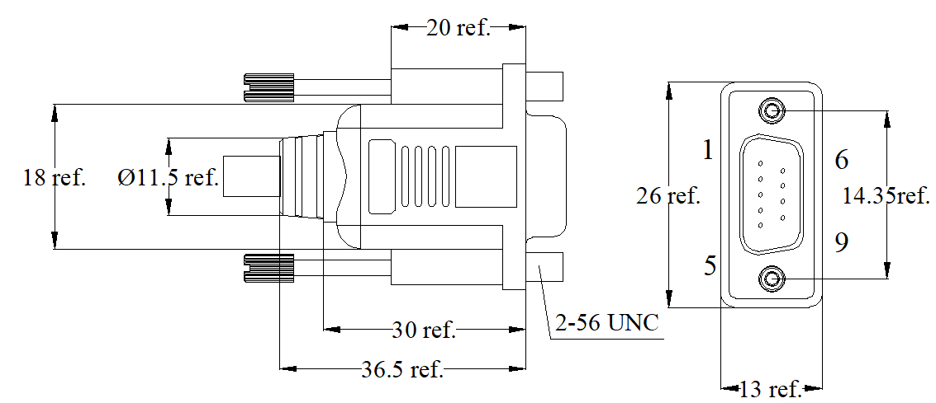

- SKU Table
SKU No. | Poles | Conn. Type | Overmoding Type | Remark
T-MDSUBSTF-09-001 | 9 | Female | Straight
T-MDSUBRAF-09-001 | 9 | Female | Right Angle
T-MDSUBSTF-15-001 | 15 | Female | Straight
T-MDSUBRAF-15-001 | 15 | Female | Right Angle
T-MDSUBSTF-25-001 | 25 | Female | Straight
T-MDSUBRAF-25-001 | 25 | Female | Right Angle

- General Information of Cable Assembly
Rated Current | 1A Max.
Rated Voltage | 30V
Insulation Resistance | ≥100MΩ
Contact Resistance | ≤5Ω
Operation Temperature | -20℃ ~+80℃
Poles | 9, 15, 25 Poles straight/right angle can be customized (Refer to below SKU table)
Cable | PUR/PVC cable (26-28AWG) options
Water Resistance | IP67 in lock condition can be customized if need

- Dimensions of Connector (Unit is mm)
Connector
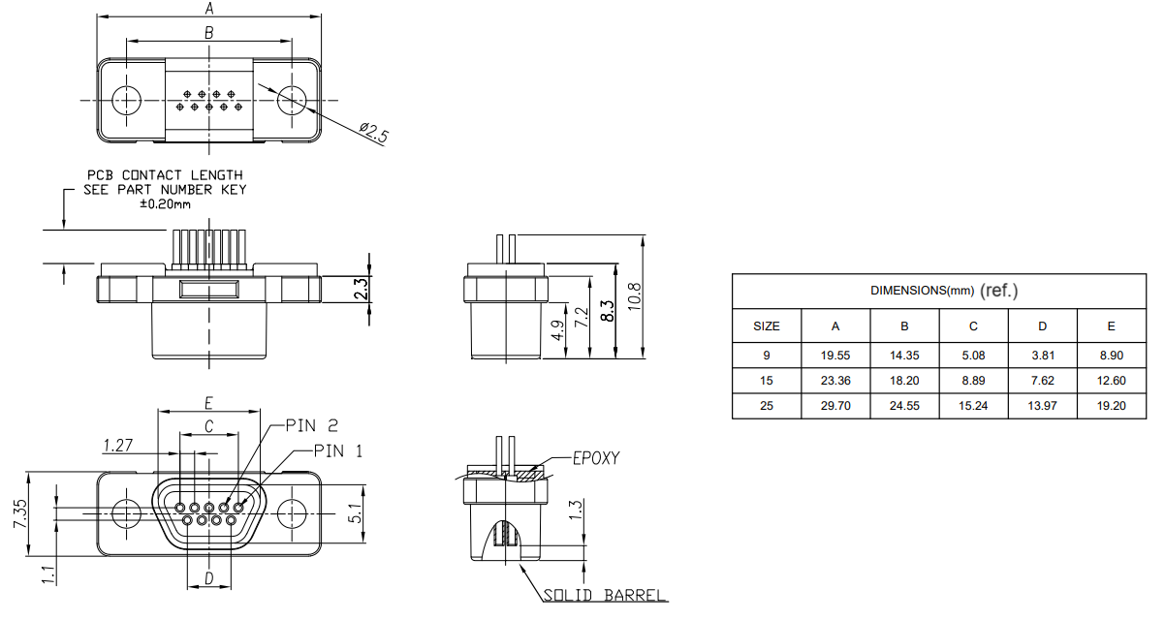

- General Information of Connector

Ambient Temperature: -35℃ ~ +85℃ Insulation Resistance: ≥100MΩ
Connector Body: PBT Contact Resistance: 45mΩ max.
Connector Contacts: Brass with nickel/gold plated Shell: Available
Pitch： 1.27mm Mating Endurance: 500 Cycles

USB 2.0 Type A Female Molded Cable Assembly, Straight
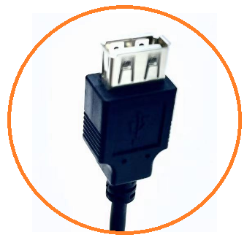

- Dimensions of Cable Assembly (Unit is mm)

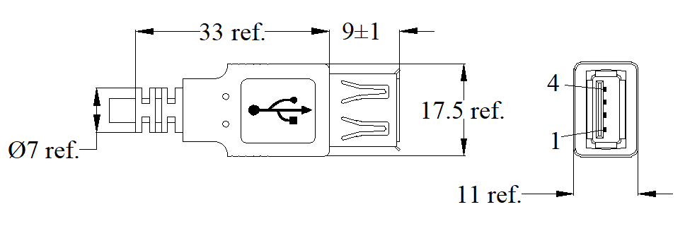

- SKU Table
SKU No. | Poles | Conn. Type | Overmoding Type | Remark
T-USB2.0ASTF-04-001 | 4 | Female | Straight

- General Information of Cable Assembly
Rated Current | 1.5A Max.
Rated Voltage | 30V
Insulation Resistance | ≥100MΩ
Contact Resistance | ≤5Ω
Operation Temperature | -20℃ ~+80℃
Poles | 4 Poles straight is available, refer to below SKU table
Cable | USB2.0 24-28AWG cable ,PUR/PVC options

- Related Components (Unit is mm)
Connector
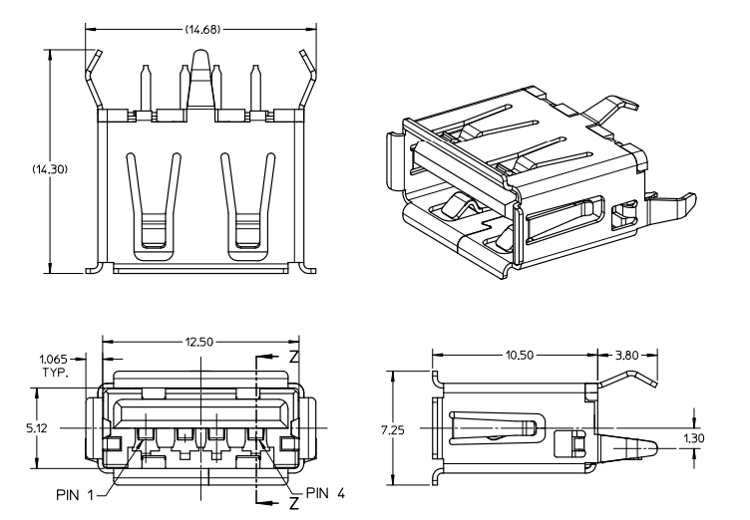
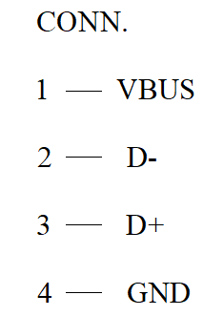

- General Information of Connector
Ambient Temperature: -20℃ ~ +80℃ Insulation Resistance: ≥100MΩ
Connector Body: PBT, BLK/WHT Contact Resistance: 30mΩ Max.
Connector Contacts: Copper Alloy with gold plated Shell: Stainless steel
Fire Resistance： UL94V-0 Insert Force: 35N max.

USB 2.0 Type A Male Molded Cable Assembly, Straight
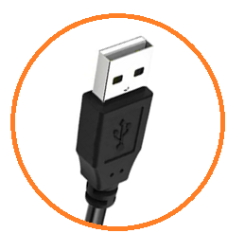

- Dimensions of Cable Assembly (Unit is mm)

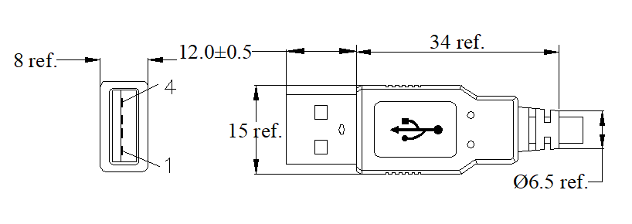

- General Information of Cable Assembly
Rated Current | 1.5A Max.
Rated Voltage | 30V
Insulation Resistance | ≥100MΩ
Contact Resistance | ≤5Ω
Operation Temperature | -20℃ ~+80℃
Poles | 4 Poles straight is available, refer to below SKU table
Cable | USB2.0 24-28AWG cable ,PUR/PVC options

- SKU Table
SKU No. | Poles | Conn. Type | Overmoding Type | Remark
T-USB2.0ASTM-04-001 | 4 | Male | Straight

- Dimensions of Connector (Unit is mm)
Connector
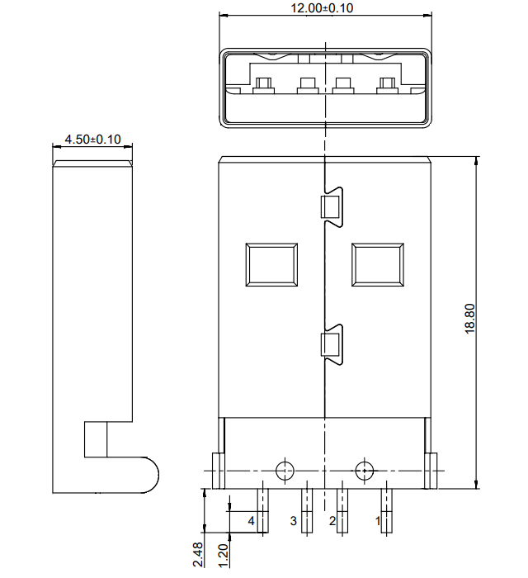

- General Information of Connector

Ambient Temperature: -20℃ ~ +80℃ Insulation Resistance: ≥100MΩ
Connector Body: PBT, BLK/WHT Contact Resistance: 30mΩ Max.
Connector Contacts: Phosphor Bronze with gold plated Shell: Stainless steel
Fire Resistance： UL94V-0 Insert Force: 35N max.

USB 2.0 Type A Male Molded Cable Assembly, Right Angle

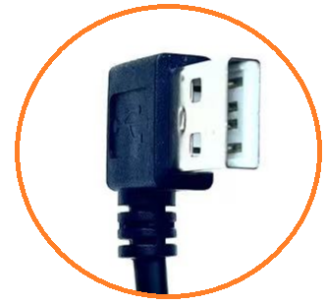

- Dimensions of Cable Assembly (Unit is mm)

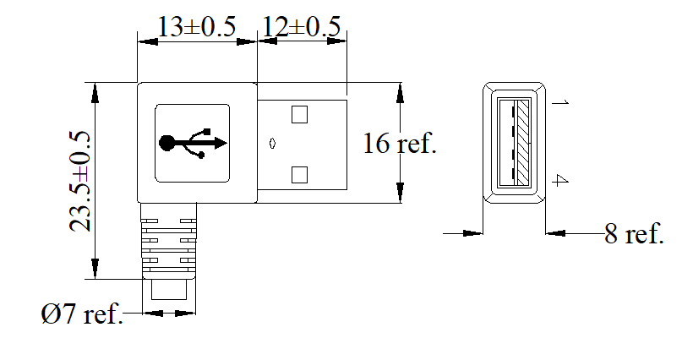

- General Information of Cable Assembly
Rated Current | 1.5A Max.
Rated Voltage | 30V
Insulation Resistance | ≥100MΩ
Contact Resistance | ≤5Ω
Operation Temperature | -20℃ ~+80℃
Poles | 4 Poles is available, refer to below SKU table
Cable | USB2.0 24-28AWG cable, PUR/PVC options

- SKU Table
SKU No. | Poles | Conn. Type | Overmoding Type | Remark
T-USB2.0ARAM-04-001 | 4 | Male | Right Angle

- Dimensions of Connector (Unit is mm)
Connector
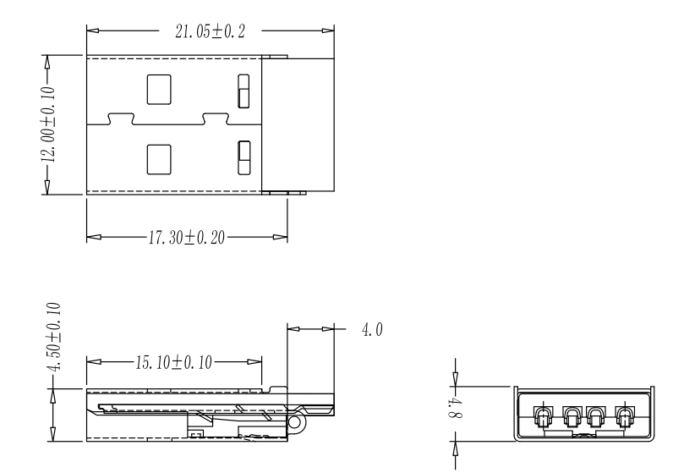

- General Information of Connector

Ambient Temperature: -20℃ ~ +80℃ Insulation Resistance: ≥100MΩ
Connector Body: PBT, BLK/WHT Contact Resistance: 30mΩ Max.
Connector Contacts: Phosphor Bronze with gold plated Shell: Stainless steel
Fire Resistance： UL94V-0 Insert Force: 35N max.

USB 2.0 Type B Male Molded Cable Assembly, Straight

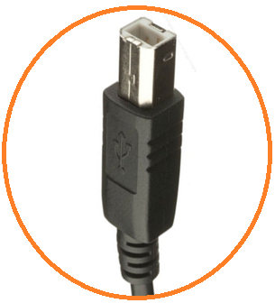

- Dimensions of Cable Assembly (Unit is mm)

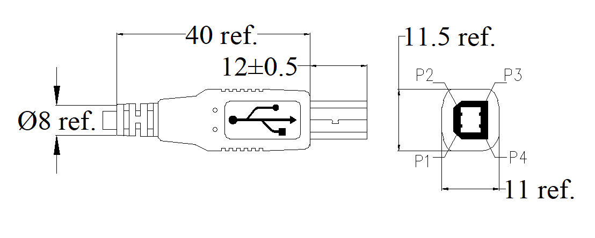

- General Information of Cable Assembly
Rated Current | 1.5A Max.
Rated Voltage | 30V
Insulation Resistance | ≥100MΩ
Contact Resistance | ≤5Ω
Operation Temperature | -20℃ ~+80℃
Poles | 4 Poles straight is available, refer to below SKU table
Cable | USB2.0 24-28AWG cable, PUR/PVC options

- SKU Table
SKU No. | Poles | Conn. Type | Overmoding Type | Remark
T-USB2.0BSTM-04-001 | 4 | Male | Straight

- Dimensions of Connector (Unit is mm)
Connector
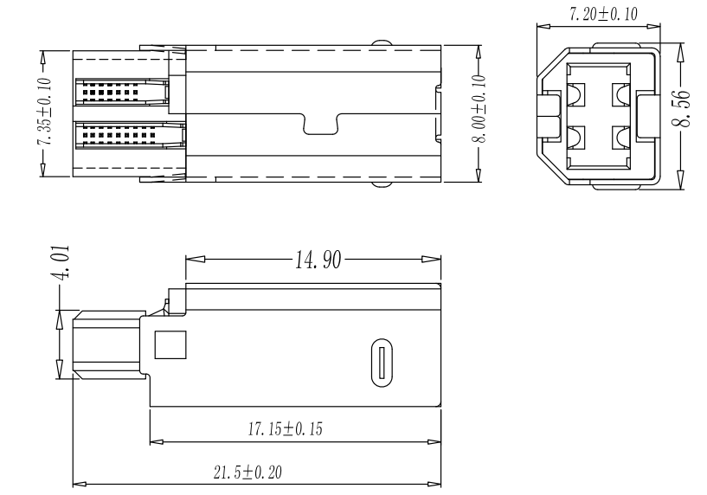

- General Information of Connector

Ambient Temperature: -20℃ ~ +80℃ Insulation Resistance: ≥100MΩ
Connector Body: PBT, BLK/WHT Contact Resistance: 30mΩ Max.
Connector Contacts: Phosphor Bronze with gold plated Shell: Stainless steel
Fire Resistance： UL94V-0 Insert Force: 35N max.

USB 2.0 Type B Male Molded Cable Assembly, Right Angle

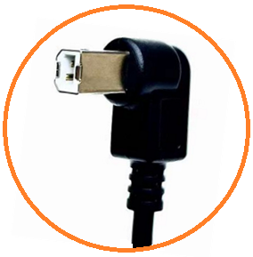

- Dimensions of Cable Assembly (Unit is mm)

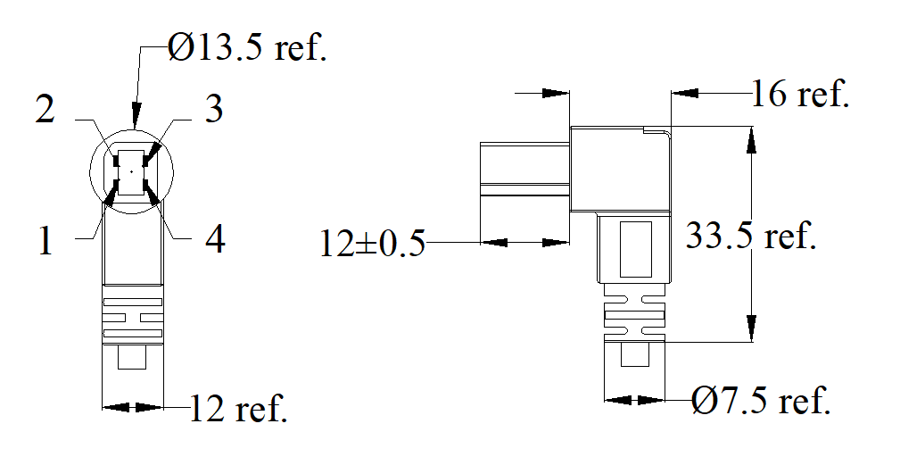

- General Information of Cable Assembly
Rated Current | 1.5A Max.
Rated Voltage | 30V
Insulation Resistance | ≥100MΩ
Contact Resistance | ≤5Ω
Operation Temperature | -20℃ ~+80℃
Poles | 4 Poles is available, refer to below SKU table
Cable | USB2.0 24-28AWG cable, PUR/PVC options

- SKU Table
SKU No. | Poles | Conn. Type | Overmoding Type | Remark
T-USB2.0BRAM-04-001 | 4 | Male | Right angle

- Dimensions of Connector (Unit is mm)
Connector

- General Information of Connector

Ambient Temperature: -20℃ ~ +80℃ Insulation Resistance: ≥100MΩ
Connector Body: PBT, BLK/WHT Contact Resistance: 30mΩ Max.
Connector Contacts: Phosphor Bronze with gold plated Shell: Stainless steel
Fire Resistance： UL94V-0 Insert Force: 35N max.

USB 2.0 Mini-B Male Molded Cable Assembly, Straight

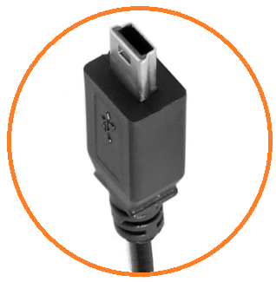

- Dimensions of Cable Assembly (Unit is mm)

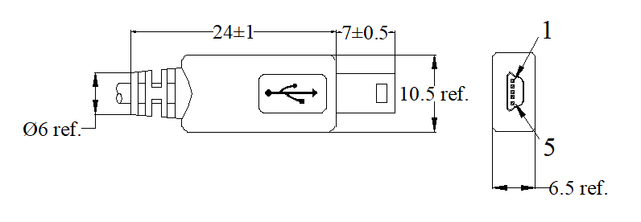

- General Information of Cable Assembly
Rated Current | 1.0 A Max.
Rated Voltage | 30V
Insulation Resistance | ≥100MΩ
Contact Resistance | ≤5Ω
Operation Temperature | -20℃ ~+60℃
Poles | 5 Poles straight is available, right angle can be customized, refer to below SKU table
Cable | USB2.0 24-28AWG cable, PUR/PVC options

- SKU Table
SKU No. | Poles | Conn. Type | Overmoding Type | Remark
T-USB2.0MINBSTM-05-001 | 5 | Male | Straight
T-USB2.0MINBRAM-05-001 | 5 | Male | Right Angle

- Dimensions of Connector (Unit is mm)
Connector
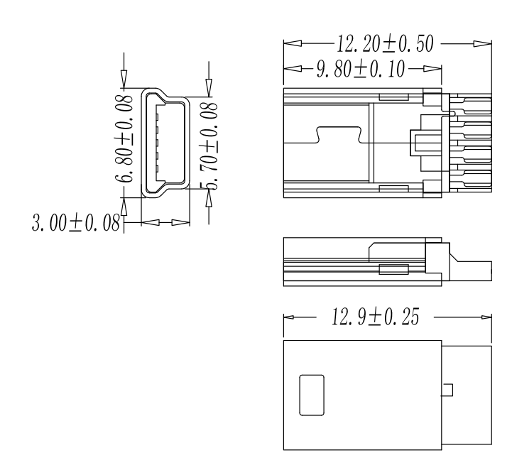

- General Information of Connector

Ambient Temperature: -20℃ ~ +60℃ Insulation Resistance: ≥100MΩ
Connector Body: PBT, BLK/WHT Contact Resistance: 30mΩ Max.
Connector Contacts: Phosphor Bronze with gold plated Shell: Stainless steel
Fire Resistance： UL94V-0 Insert Force: 35N max.

USB 2.0 Micro B Male Molded Cable Assembly, Straight

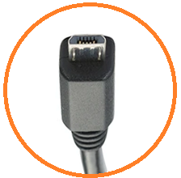

- Dimensions of Cable Assembly (Unit is mm)

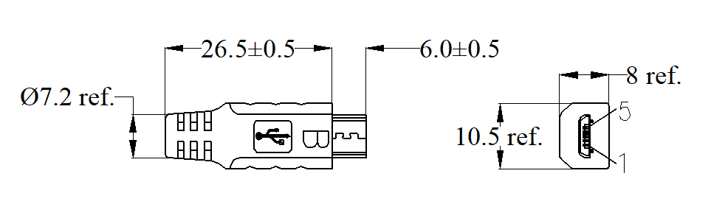

- General Information of Cable Assembly
Rated Current | Signal (Pins 2,3,4): 1.0A Max., Power (Pins 1,5): 1.8 A
Rated Voltage | 30V
Insulation Resistance | ≥100MΩ
Contact Resistance | ≤5Ω
Operation Temperature | -20℃ ~+80℃
Poles | 5 Poles is available, refer to below SKU table
Cable | USB2.0 24-28AWG cable, PUR/PVC options

- SKU Table
SKU No. | Poles | Conn. Type | Overmoding Type | Remark
T-USB2.0MICBSTM-05-001 | 5 | Male | Straight

- Dimensions of Connector (Unit is mm)
Connector
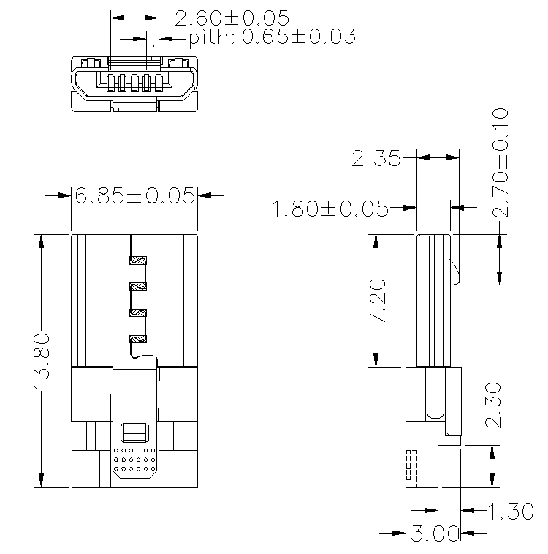

- General Information of Connector

Ambient Temperature: -20℃ ~ +80℃ Insulation Resistance: ≥100MΩ
Connector Body: PBT, BLK/WHT Contact Resistance: 50mΩ Max.
Connector Contacts: Phosphor Bronze with gold plated Shell: Stainless steel
Fire resistance： UL94V-0 Insert Force: 35N max.

USB 2.0 Micro B Male Molded Cable Assembly, right angle
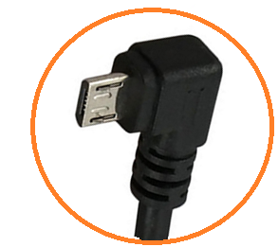

- Dimensions of Cable Assembly (Unit is mm)
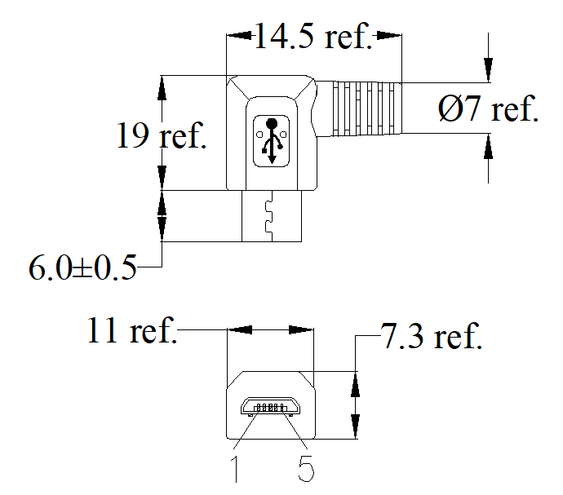

- General Information of Cable Assembly
Rated Current | Signal (Pins 2,3,4): 1.0A Max., Power (Pins 1,5): 1.8 A
Rated Voltage | 30V
Insulation Resistance | ≥100MΩ
Contact Resistance | ≤5Ω
Operation Temperature | -20℃ ~+50℃
Poles | 5 Poles is available, refer to below SKU table
Cable | USB2.0 24-28AWG cable ,PUR/PVC options

- SKU Table
SKU No. | Poles | Conn. Type | Overmoding Type | Remark
T-USB2.0MICBRAM-05-001 | 5 | Male | Right angle

- Dimensions of Connector (Unit is mm)
Connector

- General Information of Connector

Ambient Temperature: -20℃ ~+80℃ Insulation Resistance: ≥100MΩ
Connector Body: PBT, BLK/WHT Contact Resistance: 50mΩ Max.
Connector Contacts: Phosphor Bronze with gold plated Shell: Stainless steel
Fire resistance： UL94V-0 Insert Force: 35N max.

USB 3.0 Type A Female Molded Cable Assembly
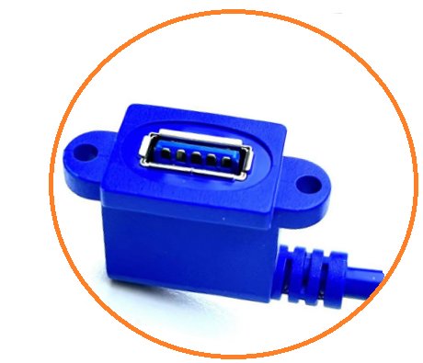

- Dimensions of Cable Assembly (Unit is mm)
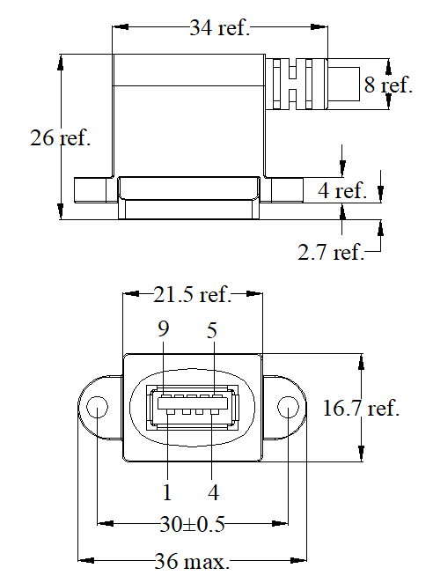

- SKU Table
SKU No. | Poles | Conn. Type | Overmoding Type | Remark
T-USB3.0ARAF-09-001 | 9 | Female | Right Angle
T-USB3.0ASTF-09-001 | 9 | Female | Straight

- General Information of Cable Assembly
Transmission Speed | 5Gbps(640MB/s)
Rated Voltage | 30V
Insulation Resistance | ≥100MΩ
Contact Resistance | ≤5Ω
Operation Temperature | -20℃ ~+80℃
Poles | 9 Poles right angle is available, straight can be customized ( Refer to SKU table）
Cable | PUR/PVC cable (28AWG) options

- Related Components (Unit is mm, refer to if it is without tolerance)
Connector
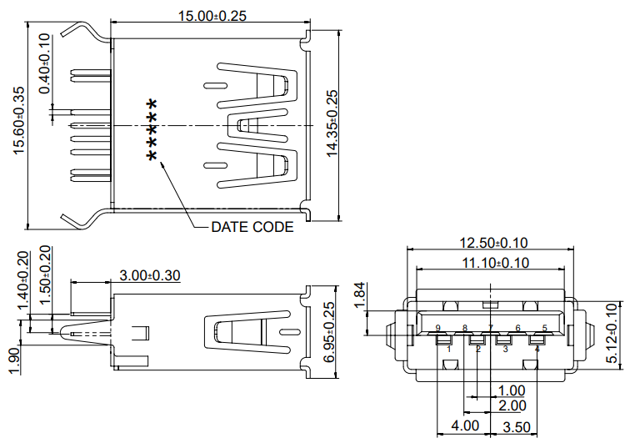
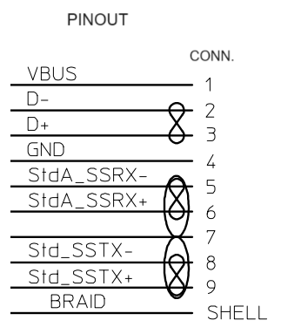

- General Information of Connector
Ambient Temperature: -20℃ ~ +80℃ Insulation Resistance: ≥100MΩ
Connector Body: PBT, Blue Contact Resistance: 50mΩ Max.
Connector Contacts: Copper Alloy with gold plated Shell: Stainless steel
Fire resistance： UL94V-0 Mating Force: 3.57KG max.

USB 3.0 Type A Male Molded Cable Assembly, Straight

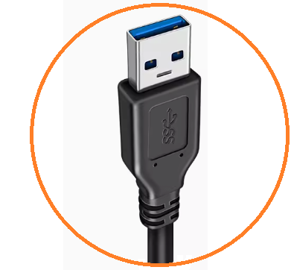

- Dimensions of Cable Assembly (Unit is mm, refer to if it is without tolerance)
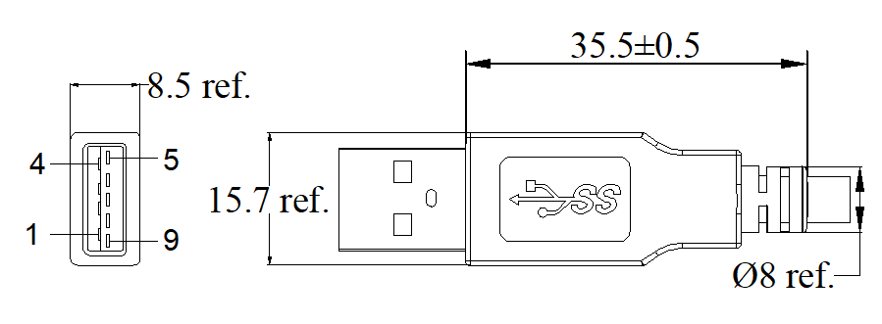

- General Information of Cable Assembly
Transmission Speed | 5Gbps(640MB/s)
Rated Voltage | 30V
Insulation Resistance | ≥100MΩ
Contact Resistance | ≤5Ω
Operation Temperature | -20℃ ~+80℃
Poles | 9 Poles straight are available,  9 Poles right angle can be customized （Refer to below SKU table）
Cable | PUR/PVC cable (28AWG) options

- SKU Table
SKU No. | Poles | Conn. Type | Overmoding Type | Remark
T-USB3.0ASTM-09-001 | 9 | Male | Straight
T-USB3.0ARAM-09-001 | 9 | Male | Right Angle

- Dimensions of Connector (Unit is mm, refer to if it is without tolerance)
Connector

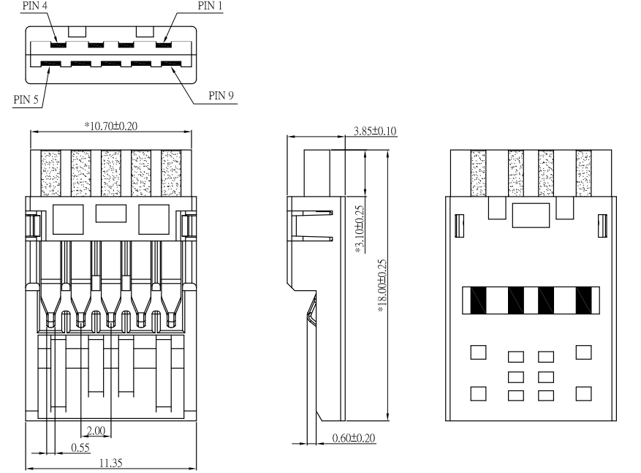

- General Information of Connector

Ambient Temperature: -20℃ ~ +80℃ Insulation Resistance: ≥100MΩ
Connector Body: PBT, blue Contact Resistance: 50mΩ Max.
Connector Contacts: Phosphor Bronze with gold plated Shell: Available
Fire resistance： UL94V-0 Mating Force: 3.57KG max.

USB 3.0 Micro-B Male Molded Cable Assembly, Straight

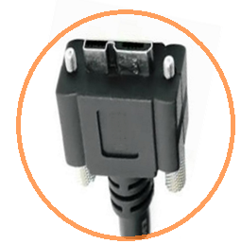

- Dimensions of Cable Assembly (mm, refer to if it is without tolerance)
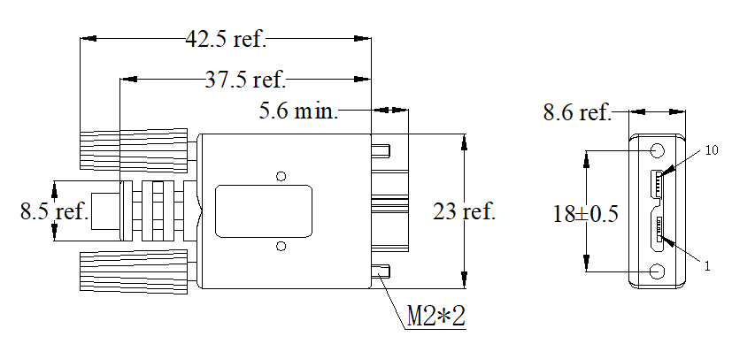

- SKU Table
SKU No. | Poles | Conn. Type | Overmoding Type | Remark
T-USB3.0MICBSTM-10-001 | 10 | Male | Straight

- General Information of Cable Assembly
Transmission Speed | 5Gbps(640MB/s)
Rated Voltage | 30V
Insulation Resistance | ≥10MΩ
Contact Resistance | ≤3Ω
Operation Temperature | -20℃ ~+80℃
Poles | 10 Poles straight are available, Refer to below SKU table
Cable | PUR/PVC cable (28AWG) options

- Dimensions of Connector (Unit is mm, refer to if it is without tolerance)
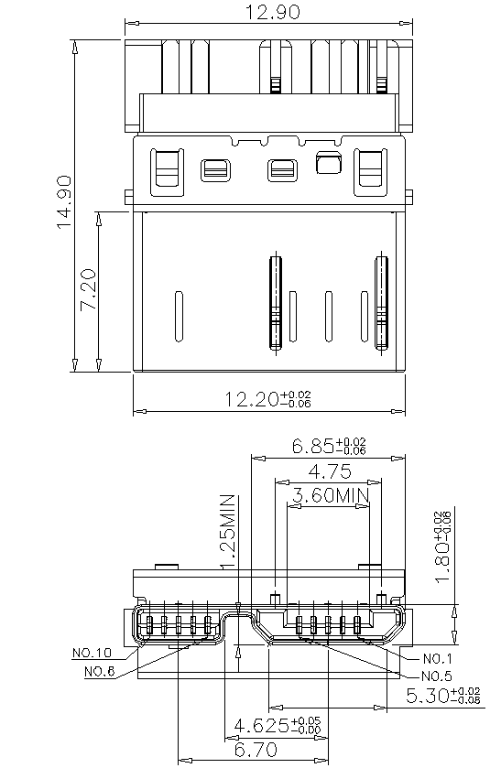

- General Information of Connector

Ambient Temperature: -20℃ ~ +80℃ Insulation Resistance: ≥100MΩ
Connector Body: PBT, black Contact Resistance: 50mΩ Max.
Connector Contacts: Phosphor Bronze with gold plated Shell: Available
Fire resistance： UL94V-0 Mating Force: 3.57KG max.

Type C Male Molded Cable Assembly, Straight

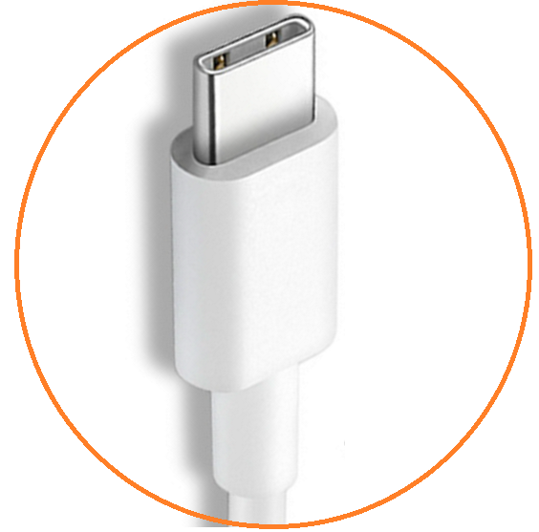

- Dimensions of Cable Assembly (Unit is mm, refer to if it is without tolerance)
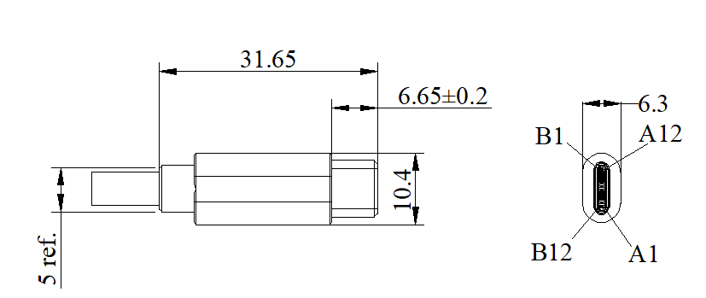

- General Information of Cable Assembly
Transmission Speed | 10Gbit (1000MB/s)
Rated Voltage | 30V
Rated Current/Power delivery | 5A Max. /Also provide the 100W (20V/5A) electric power
Insulation Resistance | ≥10MΩ
Contact Resistance | ≤3Ω
Operation Temperature | -20℃ ~+80℃
Poles | A12+B12 Poles straight and right angle are available, Refer to below SKU table
Cable | PUR/PVC cable (28-32AWG) options

- SKU Table
SKU No. | Poles | Conn. Type | Overmoding Type | Remark
T-USB3.0TCSTM-24-001 | 24 | Male | Straight
T-USB3.0TCRAM-24-001 | 24 | Male | Right angle

- Dimensions of Connector (Unit is mm, refer to if it is without tolerance)

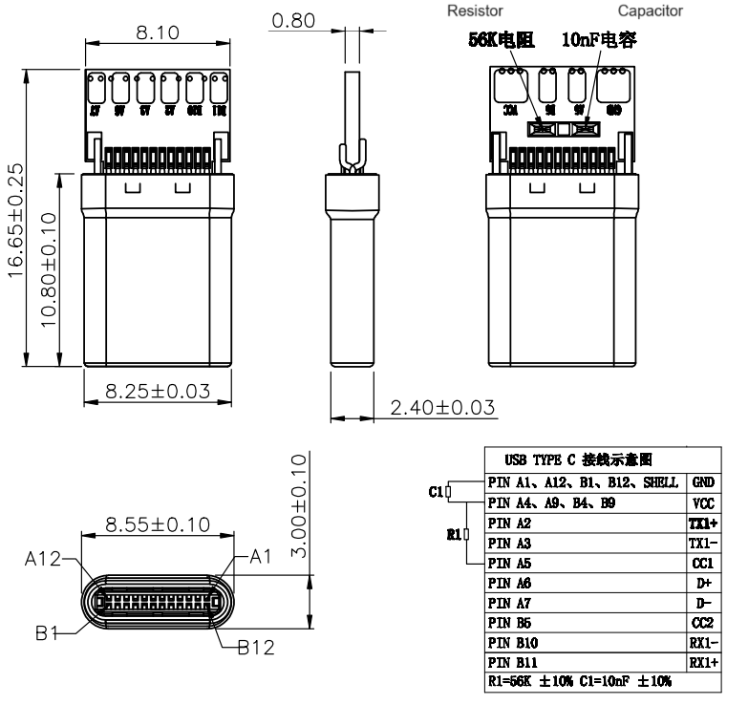

Pinout definition of male
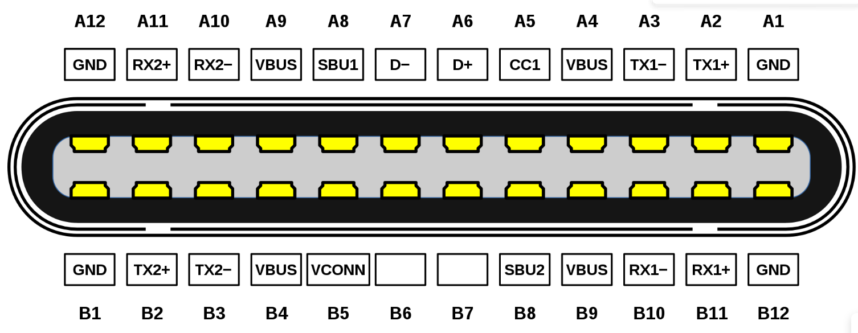

- General Information of Connector

Ambient Temperature: -55℃ ~ +85℃ Insulation Resistance: ≥100MΩ
Connector Body: PBT, black Contact Resistance: 30mΩ Max.
Connector Contacts: Phosphor Bronze with gold plated Life Cycles: 10K Times
Fire resistance： UL94V-0 Mating/Pull Force: 3.57Kgf max./1.02Kgf Min.

